Nanochemistry for the solution of mixed agriculture problems and improvement of environmental state
Ludmila Suvorovaª*, Tatyana V. Krupska^{b}, Vladimir V. Тurov^{b}, Paulius Jovaisasª
ªMacrosor, LT, Vilnius, Lithuania.
^{b}Chuiko Institute of Surface Chemistry, Kyiv, Ukraine

*Corresponding author (Phone: + 79(18) 8856937; macrosorb.lana@gmail.com).

The modern science offers the opportunity to create a complex system of nanocomposite materials production which may be used in different spheres: to increase yield in crop production, to increase the disease-resistance of farm animals and their productivity, to increase the storage life of feed and to create the means of microbiological purification of contaminated soils and water. The basis may be the hydrophilic and hydrophobic nanosilicas (SiO₂ and MeSiO₂) which with a certain ratio act as carriers of natural and mineral fertilizers, nanofungicides, medicinal or biologically active substances, microbial preparations, natural growth stimulators for plants and related substances. The multidirectional nanocomposite materials can be produced within one technological cycle, the scheme of which is given in the following figure.
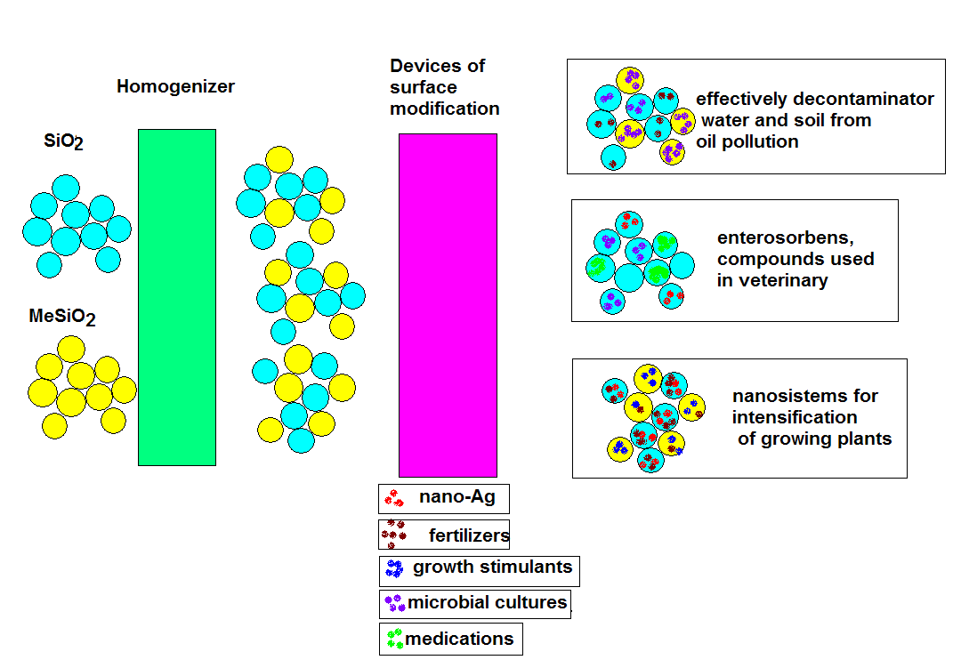

Figure 1.The scheme of technological cycle

It is planned to prepare for production several protective-stimulating compositions. Such compositions are intended to be used for pre-sowing treatment of plant seeds. Compounds used for treatment of seeds, are based on hydrophobic nanosilica, nanofugicides, growth stimulators and are suitable for all types of agricultural and ornamental plants and flowers; also they can be used by the seed industry as well as by and farmers and gardeners. The required quantity of such composite is only 1-5 wt% based on the mass of the seeds. The suggested composition is nontoxic and resistant to many microorganisms, it is able to stimulate the growth of plants in the initial growth period, which ultimately leads to increased yields of many types of crop by 10-15%.
Based on the nanosilica “Silasita” (Maсrosorb LT) it is planned to produce several compacted forms of this material which will have the same adsorbing ability and pharmacological properties, but will take 3-5 times smaller volume, which is especially important during feeding of birds and animals. Such compacted material can also be used as biostimulating additive into liquid bacterial media used in livestock. It is estimated that the application of such additive may lead to a 10-30% decrease in livestock losses.
On order to procure the most effective destruction of hydrocarbons in aqueous media and soil (bioremediation of water and soil), it is planned to develop a nanocomposite system, which will undergo a controlled division into sub-components upon incorporation of such system into water. One part of such nanocomposite system will be centered on the surface of the water mirror and will be responsible for binding and recovery (utilization) hydrocarbon film on water surface. Another part of this nanocomposite system will sink down and create a dispersion in water which will bind dissolved or emulsified hydrocarbons. And finally the third part of such system will realize the contact between bacterial cultures and bottom hydrocarbon contamination.

