RURAL AGENCY FOR COMMUNITY ACTION PROGRAMME-SIERRA LEONE (RACAP-SL)
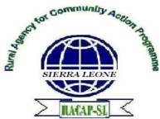
# 8 Jah Section Pujehun Town,
Tel: +232 76 897 387/+232 78 512 448
E-mail: racapsl2008@gmail.com/fawundu.racap@yahoo.com

FROM: The Executive Director
RACAP-SL
TO: Grant Officer
Water Action Hub.
DATE: 4th April, 2020

Brief update on coronavirus and request for support to emergency response in our district – Pujehun.

Dear Sir/Madam,

Rural Agency for Community Action Programme- Sierra Leone (RACAP-SL) is a registered Civil Society and Non-Governmental Oorganization (NNGO), that was established as a CBO in the Pujehun District in 2008. Since its establishment, the organization has continued to work in communities and chiefdoms of Pujehun District. However, over the years, RACAP-SL has expanded its operations into chiefdoms and communities in Bo, Bonthe and Moyamba Districts, while our National Coordinating Secretariat is based in Pujehun.

Until recently, RACAP-SL has been directly delivering services in the areas of rights promotion (with a strong bias towards women and child’s rights), educational support to extremely deprived and marginalized children, WASH promotion in communities and schools, distance learning for untrained and unqualified teachers in remote villages-poor policy advocacy for service delivery, human security and infrastructure development. Based on the current needs of local communities and small-scale business groups, RACAP expanding its activities to cover the provision of small-grants/ seed capital and loans to support the establishment of enterprises. This has necessitated the restructuring and registration of someone communities with existing or Start up or cooperative CBO/FBO level groups in Pujehun, Moyamba, Bonthe and Bo Districts.

There has been a major program shift focusing our goals and efforts on securing the rights of poor and marginalized people, especially person with disability and peace promotion. Current program priorities include rights promotion, Environmental protection (with emphasis on women and children) and HIV and AIDS, the right to education, human security promotion and the right to just and democratic governance. As part of efforts in complementing the Government of Sierra Leone’s education drive, we have also been involved in monitoring the Free Quality Education Programme recently initiated by the Government of Sierra Leone.

For your attention, As coronavirus is rapidly spreading in the world, with all efforts the Government of Sierra Leone and partners including all its citizens had been applying through social mobilization activities, frequent hand washing massages, distribution of IEC materials, radio engagement by stakeholders at both national and district level on dangers of COVID-19 as preventive measures with the aim to stop this deadly disease not to enter into Sierra Leone.

Unfortunately to all Sierra Leoneans one (1) confirmed case of coronavirus were registered on 31st of March 2020 and on the 1st April 2020 another one (1) case were also registered while on the 4th this same month two (2) confirmed cases has been registered. There are now total of four (4) confirmed cases in Sierra Leone at the moment. However the Government of Sierra Leone has urged all district local councils and ministry of health and sanitation authorities to effectively handled the fight against COVID-19 in their various districts while the Central Government will be coordinating and supervising at national level.

The sad situations in our part is that our district – Pujehun is located within the four (4) districts in the Southern Region of Sierra Leone and also share border with Liberia while Liberia now has six (6) confirmed cases which has become a very serious concerned to all stakeholders in Pujehun District. Currently Pujehun District have quarantined eight (8) suspected persons at Jendema village since the 30th of March, 2020 which is one of the communities situated at the border to Liberia. Among the eight (8) quarantined persons, all of them came from Liberia which seven (7) are Ghanaians and one (1) Sierra Leonean while they are under close observations by health workers and security personnel.

However, Pujehun District have instituted District Emergency Operation Centre (DEOC). This center is comprising of all district Government officials, local authorities both local and international partners security personnel and civil society organizations and it is headed and coordinated by the District Local Council and Ministry of Health and Sanitation authorities. This center has established various pillars to managed/controlled the affairs of COVID-19 pandemic fight. These pillars include:
- Logistic Pilar
- Social Mobilization Pillar
- WASH Pillar
- Psychosocial Pillar
- Case Management Pillar
- Surveillance Pillar etc.
Which RACAP was mandated to lead WASH pillar which has become a huge challenge for the management of RACAP because of lack of support while the limited resources through contributions of some key stakeholders from the district is not enough for our planned activities to fight against this deadly disease. Some of our planned activities includes:
- Sensitization and education of frequent hand washing practice
- Training of communities on the importance of hygiene and sanitation promotion
- Training of community mobilizers at chiefdom level for the dissemination of key massages on preventive measures on COVID-19 including the distribution of IEC materials at community level
- Radio engagement programs on preventive measures on coronavirus
- Training of community stakeholders at sectional level of hygiene and sanitation promotion in their respective communities.
- Provision of WASH facilities to all quarantined homes to save lives
- Provision of safe drinking water in all quarantined homes
- Develop jingles on preventive measures of COVID-19 which can be frequent use in various community radios
- Provision of veronica buckets, hand sanitizers, soap to all public places, strategic homes, offices, all quarantined homes and especially communities around the border

These are our planned activities submitted to the District Emergency Operation Centre (DEOC) and only few community stakeholders have started limited resources to this request while waiting for Government intervention or donor support.

However, every morning all these pillars meet at DEOC for briefings/updates for all activities

Sample of all pillars updates every morning

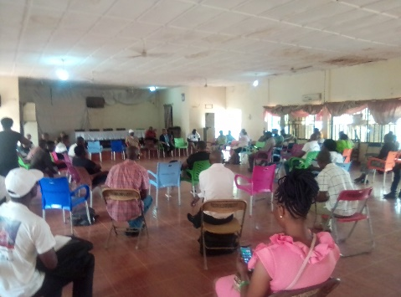
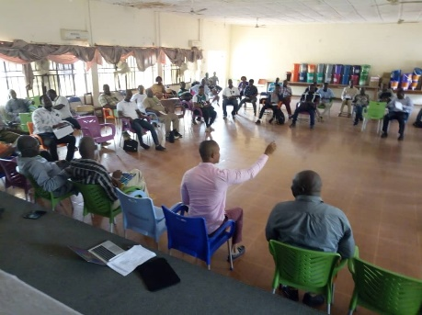

This meeting was commenced on the 29th March, 2020 at District Emergency Operation Centre (DEOC) for every day update activities from all pillars. The man pointing hand is the District Medical Officer (DMO) – Pujehun District addressing all stakeholders on COVID-19 dangers.
On the 2nd April, 2020 meeting held at District Emergency Operation Centre (DEOC) for every day update activities from all pillars

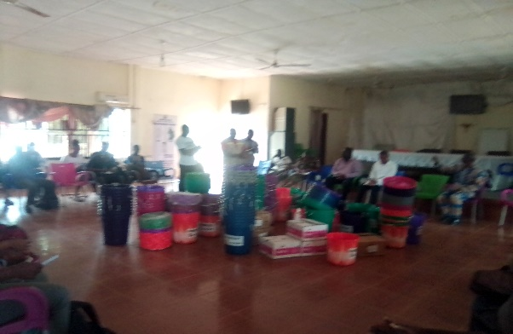

On the 31st of March, 2020 Save the children international working in Pujehun District donated some logistics to DEOC as their own contribution for the fight of COVID-19 in Pujehun District. (5 dozen of veronica buckets, 6 cottons of soap and 4 dozen of hand sanitizers)

It is against this backdrop, that the board and management of RACAP-SL are requesting your organization for support to addressed some of the above-mentioned activities to save the lives of vulnerable and marginalized communities including suspected people living in the quarantined homes in Pujehun District.
Although the board and management of RACAP-SL are very aware of the fact that Water Action Hub Organization is not currently working in Sierra Leone but due to the spread of this COVID-19 deadly pandemic globally have urged the management of our organization to ask Water Action Hub management to consider our request in order to save the lives of our poor and vulnerable people in Pujehun District to be specific and the country in general

I thank you in anticipation of kind and your prompt response.

Emmanuel M. Fawundu
Executive Director
RACAP-SL

