**DEPARTMENT OF CIVIL ENGINEERING**

DESIGNINING A SIMPLE DOMESTIC SAND FILTER FOR PURIFICATION OF DRINKING WATER

**MUGISA ROGERS**

Submitted in partial fulfilment of the requirements for the award of the Degree of Bachelor of Civil Engineering

April 11, 2022

# DECLARATION

I, ………………………………………….. do hereby declare that the work presented in this project report is prepared by me and has not been previously submitted to any other university, college and organization for any academic award.

Name: …………………………………… Registration Number: …………………….

Signature: ……………………………….. Date: ……………………….……………..

# APPROVAL

This is to certify that this research project titled …………………………………………………… ………………..…………………………… ……………………………………………………………………………….. has been fully supervised and found worthy of acceptance in partial fulfillment of the award of Bachelor of Civil Engineering.

Name: …………………………..……… Signature: ……………. Date: …………..

# DEDICATION

I dedicate this report to the Almighty God who has enabled me, my family, friends and supervisors to get through my academic journey to this stage.

In a special way I dedicate this report to my parent, my family, friends, supervisors and lecturers for all the knowledge, support and guidance the have always given to me.

# ACKNOWLEDGEMENTS

I thank the Almighty God for the gift of life, courage and determination throughout this academic experience.

I express my sincere gratitude and honest reverence to my supervisor, Mr. Tibenderana Philip for taking time off his busy schedule to support and guide this research and design experience.

I also thank the laboratory team from South Western Umbrella of Water and Sanitation for their gracious contributions and efforts in the advancement of this research. I thank them for all the time they invested and the numerous hours we spent together working on this project.

Lastly, I would like to acknowledge the constant guidance, counsel and financial support of my parents. May the good Lord bless you and all your endeavors. This research would not have been possible without you.

To all those who train and contribute to the Civil Engineering profession, may the Almighty God bless the works of your hands.

# ABSTRACT

The world’s first documented use of filtration to treat water occurred in 1804 in Paisley, Scotland at a bleachery. In 1829, the city of London adopted slow sand filtration for public supply. In 1855 and after, the work by John Snow, Louis Pasteur, Robert Koch, Theodor Escherich, and others verified that many bacteria and diseases were transferred by water. And some of the diseases include diarrhea, cholera, dysentery, typhoid and polio.

In 2017, the World Health Organization (WHO) published that 785 million people worldwide lack a basic drinking water service including 144 million people who depend on surface water. And among these are people who live in communities with surface water sources in Uganda like the people living along river Kiruruma in Kabale Municipality.

It is in this quest for providing easy access to safe drinking water that I came up with the design of a domestic sand filter that can be assembled and used at home.

I carried out tests on water samples obtained from river Kiruruma both before and after filtration and I compared them with the allowable values by WHO.

And from the results I came up with some conclusions help increase access to safe drinking water in Uganda as in the document below.

**TABLE OF CONTENT**

[DECLARATION i](#_Toc100405375)

[APPROVAL ii](#_Toc100405376)

[DEDICATION iii](#_Toc100405377)

[ACKNOWLEDGEMENTS iv](#_Toc100405378)

[ABSTRACT v](#_Toc100405379)

[LIST OF TABLES viii](#_Toc100405380)

[LIST OF FIGURES ix](#_Toc100405381)

[1 INTRODUCTION 1](#_Toc100405382)

[1.1. Background 1](#_Toc100405383)

[1.2. Problem Statement 3](#_Toc100405384)

[1.3. Objectives 3](#_Toc100405385)

[1.4. Significance 3](#_Toc100405386)

[1.5. Scope 3](#_Toc100405387)

[2 LITERATURE REVIEW 4](#_Toc100405388)

[2.1 SURFACE WATER 4](#_Toc100405389)

[2.2 CHARACTERISTICS OF SURFACE WATER 4](#_Toc100405390)

[2.2.1 PH of water 4](#_Toc100405391)

[2.2.2 Color 5](#_Toc100405392)

[2.2.3 Temperature 5](#_Toc100405393)

[2.2.4 Turbidity 6](#_Toc100405394)

[2.2.5 Total alkalinity 6](#_Toc100405395)

[2.2.6 Electric conductivity 7](#_Toc100405396)

[2.2.7 Chlorides 7](#_Toc100405397)

[2.2.8 Iron 8](#_Toc100405398)

[2.2.9 Ammonia 8](#_Toc100405399)

[2.2.10 Faecal coli forms 9](#_Toc100405400)

[2.2.11 Total coli forms 10](#_Toc100405401)

[2.3 FILTRATION 10](#_Toc100405402)

[2.3.1 SLOW SAND FILTRATION 10](#_Toc100405403)

[2.3.2 RAPID SAND FILTRATION 11](#_Toc100405404)

[3 METHODOLOGY 14](#_Toc100405405)

[3.1 SAMPLE COLLECTION. 14](#_Toc100405406)

[3.2 LABORATORY ANALYSIS 14](#_Toc100405407)

[3.2.1 Testing for pH using a pH meter. 14](#_Toc100405408)

[3.2.2 Testing for Turbidity using a Turbid Meter. 15](#_Toc100405409)

[3.2.3 Testing for Electric Conductivity using an EC Meter. 15](#_Toc100405410)

[3.2.4 Testing for Color using a Photometer. 16](#_Toc100405411)

[3.2.5 Testing for Alkalinity using a Photometer. 16](#_Toc100405412)

[3.2.6 Testing for Chlorides using a Photometer. 17](#_Toc100405413)

[3.2.7 Testing for Ammonia using a Photometer. 18](#_Toc100405414)

[3.2.8 Testing for Iron using a Photometer. 19](#_Toc100405415)

[3.2.9 Testing for faecal coliforms using Membrane filtration. 19](#_Toc100405416)

[3.2.10 Testing for total coliforms using Membrane filtration. 20](#_Toc100405417)

[3.3 PREPARATION OF FILTRATION MEDIA 22](#_Toc100405418)

[3.4 DESIGN OF THE FILTRATION COLUMN 23](#_Toc100405419)

[3.4.1 TEST PROTOTYPE 23](#_Toc100405420)

[3.4.2 FINAL PROTOTYPE 24](#_Toc100405421)

[3.5 IMPLEMENTATION OF THE DESIGN OF THE FILTER COLUMN 25](#_Toc100405422)

[4 RESULTS AND ANALYSIS 27](#_Toc100405423)

[4.1 RESULTS 27](#_Toc100405424)

[4.2 ANALYSIS 28](#_Toc100405425)

[5 CONCLUSION AND RECOMMENDATIONS 29](#_Toc100405426)

[5.1 CONCLUSION 29](#_Toc100405427)

[5.2 RECOMMENDATIONS 29](#_Toc100405428)

[REFERENCES 30](#_Toc100405429)

[APPENDICES 31](#_Toc100405430)

# LIST OF TABLES

[Table 1: Standard methods, specific methods and equipment. 14](#_Toc100415570)

[Table 2: Detailed Laboratory Results (Before and after filtration) 27](#_Toc100415571)

# LIST OF FIGURES

[Figure 1: Showing the colonies of coliforms. 9](file:/C:/Users/kyeswa%20joel/Desktop/FYP%20DESKTOP/Mugisa%20Rogers%20Project%20report.docx" \l "_Toc100415599)

[Figure 2: Section drawing of a simple sand filter. 11](#_Toc100415600)

[Figure 3: Section drawing of a Rapid Sand Filter 13](#_Toc100415601)

[Figure 4: Washing sand for the filtration Column. 22](file:/C:/Users/kyeswa%20joel/Desktop/FYP%20DESKTOP/Mugisa%20Rogers%20Project%20report.docx" \l "_Toc100415602)

[Figure 5: Test prototype 23](#_Toc100415603)

[Figure 6: Final Prototype 25](#_Toc100415604)

[Figure 7: Raw Sample Filtration using the test Filter. 25](#_Toc100415605)

[Figure 8: Samples before and after filtration. (L-R respectively) 26](#_Toc100415606)

# INTRODUCTION

## Background

Write here. In September 2000, after a decade of United Nations (UN) conferences and summits, world leaders adopted the United Nations Millennium Declaration. This declaration created a global partnership between nations with the goal of reducing and alleviating extreme poverty. The Sustainable Development Goals (SDGs) were established with a target deadline of 2015. Goal number 7 was to ensure environmental sustainability which involved a target to reduce by half the proportion of people without sustainable access to safe drinking water and basic sanitation. Fifteen years since, there has been significant progress made to improve access to safe, reliable water around the world. To measure this, the UNDP declared that an improved water supply included springs, protected wells, and boreholes with a pump, public taps, piped water, or rain water. (Goals, 2015)

The early Romans are credited with being the first society to effectively engineer water systems. Julius Sextus Frontinus the Water Commissioner of Rome, is recognized as the inventor of the aqua duct a bridge used to transport water from its source to villages and towns. Generations later, in 1804 the world’s first documented use of filtration to treat water occurred in Paisley, Scotland at a bleachery. In 1829, the city of London adopted slow sand filtration for public supply.

In 1855 and after, the work by John Snow, Louis Pasteur, Robert Koch, Theodor Escherich, and others verified that many bacteria and diseases were transferred by water. During this time, chlorine was also introduced as a means to create safe water and, by the 1900s the use of chlorine spread across the globe and became the most used mechanism to reduce waterborne disease. Since the 1970s and 1980s the developments of reverse osmosis filtration, ionization, membrane filtration and nanotechnology have all contributed to the array of water treatment technologies that exist today.

Access to safe water and sanitation is a basic human right as recognized by the United Nations General Assembly in 2010 World Health Organization (WHO). In 2017, 785 million people globally lack a basic drinking water service including 144 million people who are dependent on surface water. Three out of 10 people lack safely managed water services (UNICEF). Safe drinking water and hygienic toilets protect people from disease and enable societies to be more productive economically (S. Kayaga, 2009).

However, the suitability of water for various uses depends on the biological, physicochemical and radiological properties of water. Water supply and its accessibility is Goal number 6 of the Sustainable Development Goals (SDG 6), and it aims at ensuring availability (Goals, 2015) and sustainable management of water and sanitation for all by 2030 (UNDP).

Safe and affordable drinking water for all by 2030 requires that we invest in adequate infrastructure, provide sanitation facilities and encourage hygiene.

In order to achieve this target, 6.1 of SDG 6 is to have active monitoring of the microbial water quality of drinking water through the enumeration of Escherichia coli in water samples. (Goals, 2015)

Currently, the approved methods for the enumeration of E. coli in drinking water samples require the use of specialized equipment, including an electrically powered incubator, and entail complicated procedures that must be performed by trained personnel. (Sack, 1975)

## Problem Statement

About seven million Ugandans as of 2021 lack access to safe drinking water both in Urban and Rural areas. As a result people end up consuming contaminated water which results into diseases like diarrhea, cholera, dysentery, typhoid and polio. The project is to address the problem of safe drinking water to people who depend on surface water sources like rivers.

## Objectives

The main objective is to design a simple sand filter that can be easily assembled at home to enable water purification and provide safe drinking water.

The specific objectives are to:

• To review previous studies on domestic water purification.

• To design a prototype of a simple sand filter

• To determine the effectiveness of the sand filter.

## Significance

I find the project worth undertaking in order to ensure that there is easy access to pure and safe drinking water for everyone by coming up with a model of a sand filter which is easy to setup in a domestic setting and easy to use.

This will act as a technical guide on making simple sand filters at a household level and basis for future research in related areas.

This is also to fulfill requirements for award of a degree in Civil Engineering.

## Scope

Write here. This study was limited to river water that was obtained from river Kiruruma at the bridge in the valley between the Faculty of Engineering and Uganda College of commerce.

The study involved coming up with a prototype of a simple domestic sand filter.

The study involved water sample collection from river Kirurma that was tested both before and after filtration to check for pH, Color, Temperature, Turbidity, Total alkalinity, Electric conductivity, Chlorides, Iron, Ammonia, Faecal coli forms and Total coli forms.

# LITERATURE REVIEW

## SURFACE WATER

Surface water is any body of water above ground including streams, rivers, lakes, wetlands, reservoirs, and creeks. The ocean despite being saltwater is also considered surface water. Surface water participates in the hydrologic cycle or water cycle which involves the movement of water to and from the Earth’s surface.

There are three types of surface water: perennial, ephemeral and man-made.

Perennial or permanent surface water persists throughout the year and is replenished with groundwater when there is little precipitation.

Ephemeral or semi-permanent surface water exists for only part of the year and these include small creeks, lagoons, and water holes.

Man-made surface water is found in artificial structures, such as dams and constructed wetlands.

Since surface water is more easily accessible than groundwater, it is relied on for many human uses. It is an important source of drinking water and is used for the irrigation of farmland. In 2015, almost 80 percent of all water used in the United States came from surface water.

## **CHARACTERISTICS OF SURFACE WATER**

### PH of water

The technical definition of pH is that it is a measure of the activity of the hydrogen ion (H+) and is reported as the reciprocal of the logarithm of the hydrogen ion activity. Therefore water with a pH of 7 has 10-7 moles per liter of hydrogen ions; whereas, a pH of 6 has 10-6 moles per liter. The pH scale ranges from 0 to 14.

In general, water with a pH < 7 is considered acidic and with a pH > 7 is considered basic. The normal range for pH in surface water systems is 6.5 to 8.5 and for groundwater systems 6 to 8.5.

Alkalinity is a measure of the capacity of the water to resist a change in pH that would tend to make the water more acidic.

The measurement of alkalinity and pH is needed to determine the corrosivity of the water.

The pH of pure water (H20) is 7 at 25 °C, but when exposed to the carbon dioxide in the atmosphere this equilibrium results in a pH of approximately 5.2 because CO2 in the air dissolves in the water and forms carbonic acid. Because of the association of pH with atmospheric gasses and temperature.

It is strongly recommended that the water be tested for pH as soon as possible after the water sample is taken.

The pH of the water is not a measure of the strength of the acidic or basic solution and alone does not provide a full picture of the characteristics or limitations of the water supply.

### Color

The color of water varies with the ambient conditions in which that water is present.

While relatively small quantities of water appear to be colorless, pure water has a slight blue color that becomes deeper as the thickness of the observed sample increases.

The hue of water is an intrinsic property and is caused by selective absorption and scattering of white light.

Dissolved elements or suspended impurities may give water a different color.

### Temperature

Temperature is a critical water quality and environmental parameter because it governs the kinds and types of aquatic life, regulates the maximum dissolved oxygen concentration of the water and influences the rate of chemical and biological reactions.

The organisms within the ecosystem have preferred temperature regimes that change as a function of season, organism age or life stage and other environmental factors.

With respect to chemical and biological reactions, the higher the water temperature the higher the rate of chemical and metabolic reactions and the lower the amount of dissolved gases it can contain.

Seasonal variations in stream temperature may be caused by changing air temperature, solar angle, meteorological events and a number of physical aspects related to the stream and watershed.

These physical features include stream origin, velocity, vegetation types and coverage, stream configuration, land-use and percentage of impervious area in the watershed.

For example, a narrow, deep well-shaded shoreline reduces the impact of warming by the sun whereas a wide shallow stream would be more impacted by solar heating.

In warm water streams, the temperatures should not exceed 89 °F.

Cold water streams should not exceed 68 °F.

Often summer heat can cause fish kills in ponds because high temperatures reduce available dissolved oxygen in the water.

### Turbidity

Turbidity which is caused by suspended chemical and biological particles can have both water safety and aesthetic implications for drinking-water supplies.

Turbidity itself does not always represent a direct risk to public health however it can indicate the

Presence of pathogenic microorganisms and be an effective indicator of hazardous events throughout the water supply system from catchment to point of use.

For example high turbidity in source waters can harbor microbial pathogens which can be attached to particles and impair disinfection.

High turbidity in filtered water can indicate poor removal of pathogens and an increase in turbidity in distribution systems can indicate sloughing of biofilms and oxide scales or ingress of contaminants through faults such as mains breaks.

Turbidity can be easily accurately and rapidly measured and is commonly used for operational monitoring of control measures included in water safety plans (WSPs), the recommended approach to managing drinking-water quality in the WHO Guidelines for Drinking-water Quality (WHO., 2011).

It can be used as a basis for choosing between alternative source waters and for assessing the performance of a number of control measures including coagulation and clarification, filtration, disinfection and management of distribution systems.

Turbidity is also an important aesthetic parameter, with turbidities of 4 nephelometric turbidity units (NTU) and above being visible and affecting the appearance and acceptability of drinking-water to consumers.

### Total alkalinity

Total alkalinity (TA) is the measure of water’s ability to neutralize acids.

Alkaline compounds that are present in water like hydroxides and carbonates eliminate H+ ions from the water which lowers the acidity of the water and results in a higher pH.

Total alkalinity is gauged by measuring the levels of acid required to bring a certain sample’s pH level to 4.2. At this level, all alkaline compounds are completely used up.

Measuring alkalinity is vital in identifying the capacity of water to neutralize the acidic and corrosive effects from water and other sources, such as rainfall.

Total alkalinity is the measure of the alkalinity of substances present in water. When the TA level is within appropriate levels, fast pH changes are prevented which in turn balances the pH levels.

If the total alkalinity is too high it can be hard to regulate the pH.

With this, the water turns cloudy and the water may continuously need acid, depending on the results of testing. When this happens, the chlorine in the water becomes less efficient in disinfecting.

### Electric conductivity

Electrical conductivity is nothing but the measure of the capability of the material to pass the flow of electric current.

Electrical conductivity differs from one material to another depending on the ability to let the electricity flow through them.

Protons, electrons, and neutrons present in the material carry the current.

Protons carry positive charge and each electron has a negative charge that it carries with it wherever it goes.

The flow of electrons inside the material is referred to as the electric current.

The more the number of ions present in the electrolyte, then the higher is the conductivity of water. Similarly the fewer the number of ions present in water, and then less conductive is the conductivity of water.

Deionized or distilled water can also act as an insulator due to the very low value of conductivity. Seawater is said to possess a very high value of conductivity.

Pure water is said to be a bad conductor of electricity.

Normal water is said to have impurities present in the form of ions called minerals.

These ions are known to be responsible for the conduction of electric current in the water.

Because the electrical current in water is transported by the ions present in them and the electrical conductivity is said to increase with the increase in the concentration of ions in them.

The conductivity of water is a measure of the capability of water to pass electrical flow and is directly dependent on the concentration of conductive ions present in the water.

### Chlorides

Chloride in surface and groundwater from both natural and anthropogenic sources, such as run-off containing road de-icing salts, the use of inorganic fertilizers, landfill leachates, septic tank effluents, animal feeds, industrial effluents, irrigation drainage and seawater intrusion in coastal areas.

Chloride is a major component of dissolved solids. The use of road salt-sodium chloride, the same chemical as table salt for deicing is a major manmade source of chloride to surface water and groundwater. Application of road salt in the United States has tripled since the 1970s, while other uses of salt have remained stable or decreased.

Elevated concentrations of chloride in streams can be toxic to some aquatic life.

Additionally, the presence of chloride increases the potential corrosivity of the water.

Corrosion in water distribution systems affects infrastructure and drinking water quality.

### Iron

Iron is the second most abundant metal in the earth's crust, of which it accounts for about 5%.

Elemental iron is rarely found in nature, as the iron ions Fe 2+ and Fe 3+ readily combine with oxygen and sulfur-containing compounds to form oxides, hydroxides, carbonates, and sulfides.

Iron is most commonly found in nature in the form of its oxides.

In drinking-water supplies, iron (II) salts are unstable and are precipitated as insoluble iron (III) hydroxide, which settles out as a rust colored silt.

Iron also promotes undesirable bacterial growth ("iron bacteria") within a waterworks and distribution system, resulting in the deposition of a slimy coating on the piping.

Dissolution of iron can occur as a result of oxidation and decrease in pH.

### Ammonia

Ammonia (NH3) is a colorless gas with a strong pungent odor.

Ammonia will react with water to form a weak base (NH4OH ––> NH4+ + OH–).

The term ammonia refers to two nitrogen species which are in equilibrium in water. The un-ionized ammonia (NH3) and the ionized ammonium ion (NH4+).

Tests for ammonia usually measure total ammonia (NH3 plus NH4+) content. The toxicity of ammonia is primarily attributable to the un-ionized form (NH3), as opposed to the ionized form (NH4+).

In general, more NH3 and greater toxicity exist at higher pHs.

When dissolved in water, normal ammonia (NH3) reacts to form an ionized species called ammonium (NH4+):

NH3 + H2O ↔ NH4 + + OH–

This is a shorthand way of saying that one molecule of ammonia reacts with one molecule of water to form one ammonium ion and a hydroxyl ion.

From the double-headed arrow, we can tell that the reaction can go either way and hydroxyl ions and ammonium ions could combine to form ammonia and water. This is precisely what happens as the pH of water increases, that is, the water becomes more alkaline. You may recall that alkalinity is caused by an increase in hydroxyl ions. An increase in hydroxyl ions (or alkalinity) pushes the equilibrium to the left and more un-ionized ammonia is formed.

At any given time, there will be both ammonia molecules and ammonium ions present. The quantity of each species is dependent on both pH and temperature.

### Faecal coli forms

Coliform bacteria are a collection of relatively harmless microorganisms that live in large numbers in the intestines of humans and warm- and cold-blooded animals. They aid in the digestion of food.

A specific subgroup of this collection is the fecal coliform bacteria, the most common member being Escherichia coli.

These organisms may be separated from the total coliform group by their ability to grow at elevated temperatures and are associated only with the fecal material of warm-blooded animals.

The fecal coliform group includes all of the rod-shaped bacteria that are non-spore forming, Gram-Negative, lactose-fermenting in 24 hours at 44.5 °C and which can grow with or without oxygen.

Fecal coliform by themselves are usually not pathogenic; they are indicator organisms which means they may indicate the presence of other pathogenic bacteria.

Pathogens are typically present in such small amounts that it is impractical to monitor them directly.

Some strains of Escherichia coli which are a type of fecal coliform and can cause intestinal illness.

One such strain is E. coli O157:H7 which is found in the digestive tract of cattle.

The presence of fecal coliform bacteria in aquatic environments indicates that the water has been contaminated with the fecal material of humans or other animals.

At the time this occurred, the source water may have been contaminated by pathogens or disease-producing bacteria or viruses which can also exist in fecal material.

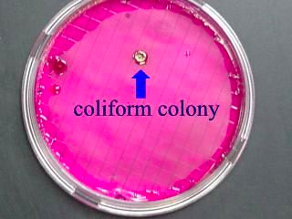

Figure 1: Showing the colonies of coliforms.

### Total coli forms

Total coliform bacteria are often considered an indicator there may be something more serious contaminating a drinking water system, specifically E. coli bacteria.

Total coliform bacteria are colorless, odorless, and tasteless and the only way it can be detected in drinking water is through submitting a sample for laboratory testing.

Bacterial contamination can result from a number of sources. These sources include surface runoff containing animal waste from feedlots, dog runs, or other locations where animal waste is deposited or piled.

Human waste can also be a bacterial contamination source most often from a failing onsite wastewater system such as residential septic tanks, laterals, mounds systems, or lagoons. Additional contamination sources include insects, rodents, or animals that may get trapped in a well and die thus introducing bacteria to the well water.

Flooding events where wellheads are submerged by floodwaters that commonly contain high levels of bacteria are yet another source of contamination.

## FILTRATION

### SLOW SAND FILTRATION

Slow sand filtration is a type of centralized or semi-centralized water purification system.

A well-designed and properly maintained slow sand filter (SSF) effectively removes turbidity and pathogenic organisms through various biological, physical and chemical processes in a single treatment step. (Lee, 2001)

Only under the prevalence of a significantly high degree of turbidity or algae-contamination, pre-treatment measures (e.g. sedimentation) become necessary. Slow sand filtration systems are characterized by a high reliability and rather low lifecycle costs.

Moreover neither construction nor operation and maintenance require more than basic skills. Hence slow sand filtration is a promising filtration method for small to medium-sized, rural communities with a fairly good quality of the initial surface water source. (Sutherland, 2008)

As stated by the WHO, slow sand filtration provides a simple but highly effective and considerably cheap tool that can contribute to a sustainable water management system.

The basic principle of the process is very simple. Contaminated freshwater flows through a layer of sand, where it not only gets physically filtered but biologically treated.

Hereby both sediments and pathogens are removed. This process is based on the ability of organisms to remove pathogens. (Lee, 2001)

Although the physical removal of sediments is an important part of the purification process, the relevant aspect is the biological filtration. The top layers of the sand become biologically active by the establishment of a microbial community on the top layer of the sand substrate, also referred to as ‘schmutzdecke’. These microbes usually come from the source water and establish a community within a matter of a few days.

The fine sand and slow filtration rate facilitate the establishment of this microbial community. The majority of the communities are predatory bacteria that feed on water-borne microbes passing through the filter (WHO, 2011).

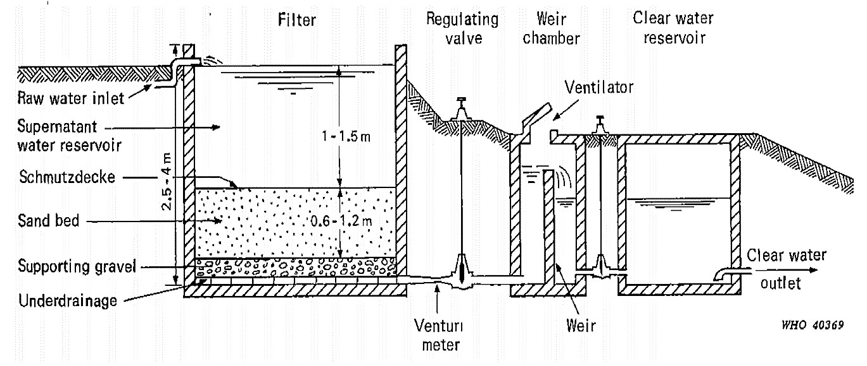

Figure 2: Section drawing of a simple sand filter.

Hence, the underlying principle of the SSF is equivalent to the bio-sand filtration.

Slow sand filtration is an extremely efficient method for removing microbial contamination and will usually have no indicator bacteria present at the outlet. SSFs are also effective in removing protozoa and viruses (WHO., 2011). If the effluent turbidity is below 1.0 nephelometric turbidity units (NTU), a 90 to 99% reduction in bacteria and viruses is achieved (NDWC 2000). Yet, slow sand filtration is generally not effective for the majority of chemicals (WHO., 2011).

Once a SSF facility is built, only clean sand is required for occasional replacement. The sand layers are put in gradually according to their grain sizes: rather coarse grains at the bottom and fine grains at the top. The sand-bed is usually covered with one meter of supernatant water (LOGSDON 2003).

As the process of biological filtration requires a fair amount of time in order to purify the water sufficiently, SSFs usually operate at slow flow rates between 0.1 – 0.3 m3/h per square meter of surface (WHO., 2011). The water thus remains in the space above the medium for several hours and larger particles are allowed to separate and settle.

### RAPID SAND FILTRATION

Rapid sand filtration is a purely physical drinking water purification method.

Rapid sand filters (RSF) provide rapid and efficient removal of relatively large suspended particles.

Two types of RSF are typically used: rapid gravity and rapid pressure sand filters.

For the provision of safe drinking water, RSFs require adequate pre-treatment (usually coagulation-flocculation) and post-treatment (usually disinfection with chlorine).

Both construction and operation is cost-intensive. It is a relatively sophisticated process usually requiring power-operated pumps, regular backwashing or cleaning and flow control of the filter outlet. Rapid sand filtration is common in developed countries for the treatment of large quantities of water where land is a strongly limiting factor and where material, skilled labor and continuous energy supply are available (Sparks, 2012).

Rapid sand filtration, in contrast to slow sand filtration, is a purely physical treatment process.

As the water flows through several layers of coarse-grained sand and gravel, relatively large particles are held back safely (Wood, 1974).

However, RSFs never provide safe drinking water without adequate pre-treatment and final disinfection. Usually, coagulation and flocculation and chlorination are applied for that purpose.

The filter chamber is usually made out of reinforced concrete, filled with sand and gravel to the height of 1.5-2 meters. (Sutherland, 2008)

The water is supplied to the top of the sand-bed and filtered as it flows through the layers of graded sand and gravel.

A system of perforated pipes on the bottom drains the chamber (WHO., 2011). The filter chamber can be constructed as open tanks (rapid gravity filters) or closed tanks (pressure filters).

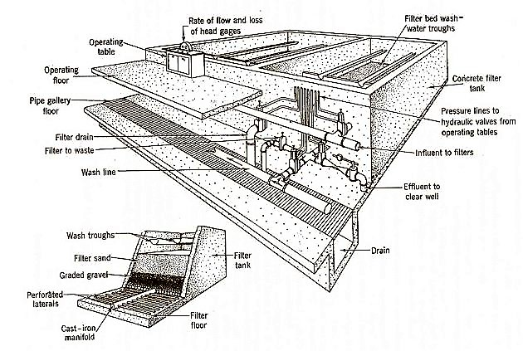

Figure 3: Section drawing of a Rapid Sand Filter

This filtering process is determined by two basic physical principles. First, relatively large suspended particles get stuck between the sand grains as they pass the filter medium (mechanical straining). Second, smaller particles adhere to the surface of the sand grains caused by the effect of the van der Waals forces (physical adsorption).

A chemical filter-aid (i.e. coagulant) might be added to promote additional adhesion (SCHMITT & SHINAULT 1996).

In the course of these processes, more and more particles accumulate in the filter medium, increasingly causing clogged filters and decreased performance.

Initial filtering performance can be re-achieved through a cleaning of the filter bed. This is usually conducted through backwashing: the flow of water is reversed, so that treated water flows backwards through the filter.

The sand is re-suspended and the solid matter is separated in the surface water. Often, air is injected additionally to support the cleaning process (WHO., 2011).

As soon as most particles are washed out and the backward flowing water is clear, the filter is put back to operation. Clearly, relatively large quantities of sludge are generated through backwashing and require some form of treatment before discharge into the environment (UNEP 1998).

# METHODOLOGY

## **SAMPLE COLLECTION**.

The sample was collected directly into the sample container since river Kiruruma was accessible.

I faced upstream since there was a current and I collected the sample without disturbing the bottom sediment. I made sure the surface water sample was collected prior to the collection of a sediment sample at the same location.

## LABORATORY ANALYSIS

All laboratory analysis was conducted using Standard Methods and the specific method and equipment that were used for analysis of each parameter.

After collection, the sample was transported to South Western Umbrella of Water and Sanitation laboratory at Kigongi in Kabale Municipality for processing within an hour. The results were recorded in the laboratory recording form as shown in the appendix and were subsequently analyzed.

The Standard methods, specific methods and equipment that were used for analysis of each parameter are as in the table below;

Table 1: Standard methods, specific methods and equipment.

|  |  |  |
| --- | --- | --- |
| **S/N** | **PARAMETER** | **EQUIPMENT** |
| 1. | pH | pH Meter |
| 2. | Turbidity | Turbid Meter |
| 3. | Electric Conductivity | EC Meter |
| 4. | Color, alkalinity, chlorides, Ammonia and Iron | Photometer (Palin test) |
| 5. | Faecal Coliforms and Total coliforms. | Pressure cooker, membrane filtration unit, incubator |

### Testing for pH using a pH meter.

* Press the ON/OFF button to switch the tester on.
* Dip the electrode about 2 to 3 cm into the test solution.
* Stir and let the reading stabilize.
* Note the pH value or press HOLD/ENT button to freeze the reading. To release the reading, press HOLD/ENT again.
* Press ON/OFF to turn off tester. If you do not press a button for 8.5 minutes, the tester will automatically shut off to conserve batteries

### Testing for Turbidity using a Turbid Meter.

* Turn meter on by pressing the Menu/on button.
* Press and hold the Menu/on button for 3 seconds to confirm that the correct range is selected. “Ch50” should be displayed in the bottom right corner indicating a 0-50 NTU range setting.
* Rinse the sensor with distilled water.
* Dry and clean the lenses with alcohol.
* Insert the sensor into the wastewater sample bottle. Make sure that the stainless steel portion of the sensor is in contact with the water and that the sensor tip is at least 3” from the bottom of the vessel.
* Wait for the sensor to stabilize. Once reading is stable, record the reading in NTUs in the field logbook.
* Clean the sensor using distilled water.
* At the end of data collection, verify the instrument’s calibration, place the sensor in its calibration environment and check to see that the meter is reading its calibration value.
* Enter this verification in the Field Data Log.
* Clean the sensor with distilled water.

### Testing for Electric Conductivity using an EC Meter.

* Bring the standard solution to room temperature (about 25° C).
* Pour standard solution into each of the two clean 100-mL beakers or cups to a depth of about 2 cm.
* Remove the cap from the electrical conductivity tester and press the On/Off button to turn it on.
* Rinse the electrode at the bottom of the tester with distilled water in the wash bottle.
* Gently blot dry with a tissue. Note: Do not rub or stroke the electrode while drying.
* Put the probe of the meter into the first beaker of standard. Stir gently for 2 seconds to rinse off any distilled water.
* Take the meter out of the first beaker. Do NOT rinse with distilled water.
* Put it into the second beaker.
* Stir gently, and then wait for the numbers to stop changing.
* If the display does not read the value of your standard solution, you must adjust the instrument to read this number. (For most meters, you can use a small screwdriver to adjust the calibration screw on the meter until the display reads the standard value)
* Rinse the electrode with distilled water and blot it dry. Turn off the meter and put the cap on to protect the electrode.
* Pour the standard from the beakers into a waste container. Rinse and dry the beakers.

### Testing for Color using a Photometer.

The color of the water is determined photo electrically using the Palintest Photometer. The sample should be filtered to remove suspended solids before analysis to determine the 'true color' due to dissolved matter. The color of water is expressed using the platinum/cobalt color scale (Pt/Co scale). Each unit is equivalent to the color produced by 1 mg/l platinum in the form of chloroplatinic acid in the presence of 2 mg/l cobaltous chloride hexahydrate. These units are identical with 'Hazen' units, which have been traditionally used to express results from the visual estimation of water colour.

**Reagents and Equipment**

* Palintest Colour/Turbidity Set (PM 269)
* Palintest Automatic Wavelength Selection Photometer

**Test Procedure**

* Filter sample through a GF/B filter paper.
* Fill a test tube with filtered sample to the 10 ml mark.
* Fill a test tube with deionized water to the 10 ml mark and retain for use as the BLANK tube.
* Select Phot 47 on photometer.
* Take photometer reading in usual manner (see photometer instructions) using the deionised water as the blank.
* The result is displayed as mg/l Pt.

**Note:** Samples, which contain metallic impurities, dyestuffs or other industrial pollutants, may exhibit a different colour to the natural yellow-brown coloration. This test may not be suitable for samples of this type.

### Testing for Alkalinity using a Photometer.

The Palintest Alkaphot test is based on a unique colorimetric method and uses a single tablet reagent. The test is simply carried out by adding a tablet to a sample of the water. Under the conditions of the test, a distinctive range of colors from yellow, through green, to blue is produced over the alkalinity range 0 - 500 mg/l CaCO3. The color produced in the test is indicative of the alkalinity of the water and is measured using a Palintest Photometer.

**Reagents and Equipment**

* Palintest Alkaphot Tablets
* Palintest Automatic Wavelength Selection Photometer
* Round Test Tubes, 10 ml glass.

**Test Procedure**

* Fill test tube with sample to the 10 ml mark.
* Add one Alkaphot tablet, crush and mix until all of the particles have dissolved.
* Stand for one minute then remix.
* Select Phot 2 on Photometer.
* Take Photometer reading in usual manner (see Photometer instructions).
* The result is displayed as mg/l CaCO3.

**Note:** To convert Total Alkalinity as CaCO3 to Total Alkalinity as HCO3- multiplies result by 1.22.

### Testing for Chlorides using a Photometer.

The Palintest Chloridol test is based on a tablet reagent system containing silver nitrate. Chlorides react with the silver nitrate to produce insoluble silver chloride. At the chloride levels encountered in the test, the insoluble silver chloride is observed as turbidity in the test sample. The degree of turbidity is proportional to the chloride concentration and is measured using a Palintest Photometer.

The test is carried out under acidic and oxidizing conditions so as to prevent interference from complexing agents such as EDTA and polyphosphates, and from any reducing substances which may be present in the water. Polyacrylates do however interfere and the test should not be used on industrial waters using polyacrylate-based treatments.

The formation of the precipitate in the Chloridol test may be subject to matrix effects in the presence of high total dissolved solids (TDS). The 0 – 50 mg/l Cl range is calibrated only for use on softened waters and condensates, and should not be used for other samples. The dilution step in the other ranges reduces the TDS to acceptable levels and prevents this effect.

**Reagents and Equipment**

* Palintest Acidifying CD Tablets
* Palintest Chloridol Tablets
* Palintest Automatic Wavelength Selection Photometer
* Round Test Tubes, 10 ml glass
* Measuring Syringe, 1 ml
* Sample Container, 100/50/10 ml plastic

**Test Calibration**

Select Program:

* Phot 46 for range 0 – 50 mg/l Cl
* or Phot 51 Range 0 – 500 mg/l Cl
* or Phot 101 Range 0 – 10,000 mg/l NaCl
* or Phot 102 Range 0 – 50,000 mg/l NaCl

**Test Instructions**

* **For Testing Boiler Condensate and Softened Waters ONLY Range 0 - 50 mg/l Cl.**

Fill test tube with sample to the 10 ml mark.

**For Testing Natural Waters, Drinking Water, Swimming Pools and Boiler Waters Range 0 - 500 mg/l Cl.**

Using the measuring syringe, take 1ml of sample. Transfer to the test tube and make-up to the 10 ml mark with deionised water.

**For Testing Salt Chlorinator Treated Swimming Pools Range 0 - 10,000 mg/l NaCI**

Using the measuring syringe, take 0.5ml of sample. Transfer to the sample container then make-up to the 100 ml mark with deionised water. Cap tube and mix. Fill test tube to the 10 ml mark with solution from the sample container.

**For Testing Sea Water and Brackish Waters Range 0 - 50,000 mg/l NaCI**

Using the measuring syringe, take 0.1 ml of sample. Transfer to the sample container then make-up to the 100 ml mark with deionised water. Cap tube and mix. Fill test tube to the 10 ml mark with solution from the sample container.

* Add one Acidifying CD tablet, crush and mix to dissolve.
* Add one Chloridol tablet, allow the tablet to disintegrate for two minutes then crush any remaining particles and mix. A cloudy solution indicates the presence of chloride.
* Select the appropriate program number on the photometer for the test range required.
* Take the photometer reading in usual manner (see Photometer instructions). Use the light cap whilst taking readings.

### Testing for Ammonia using a Photometer.

The Palintest Ammonia test is based on an indophenol method. Ammonia reacts with alkaline salicylate in the presence of chlorine to form a green-blue indophenol complex. Catalysts are incorporated to ensure complete and rapid color development. The reagents are provided in the form of two tablets for maximum convenience. The test is simply carried out by adding one of each tablet to a sample of the water. The intensity of the color produced in the test is proportional to the ammonia concentration and is measured using a Palintest Photometer.

**Reagents and Equipment**

* Palintest Ammonia No 1 Tablets
* Palintest Ammonia No 2 Tablets
* Palintest Automatic Wavelength Selection Photometer
* Round Test Tubes, 10 ml glass

**Test Instructions**

* Fill test tube with sample to the 10 ml mark.
* Add one Ammonia No 1 tablet and one Ammonia No 2 tablet, crush and mix to dissolve.
* Stand for ten minutes to allow color development.
* Select Phot 4 on Photometer to measure Ammonia mg/l N or select Phot 62 on Photometer to measure Ammonium mg/l NH4.
* Take Photometer reading in usual manner (see Photometer instructions).

### Testing for Iron using a Photometer.

In the Palintest Iron MR method iron is reduced to the ferrous form and then reacted with 1, 10-phenanthroline to form an orange coloured complex. A decomplexing agent is incorporated into the reagent system in order to break down complexed forms of iron.

The test is simply carried out by adding tablet reagents to a sample of the water under test. The intensity of the colour produced is proportional to the iron concentration and is measured using a Palintest Photometer.

Interference can occur in industrial waters treated with molybdate and nitrite based treatment products. A supplementary reagent can be used to prevent this interference.

**Reagents and Equipment**

* Palintest Iron MR No 1 Tablets
* Palintest Iron MR No 2 Tablets
* Palintest Citrate IR Tablets
* Palintest Automatic Wavelength Selection Photometer
* Round Test Tubes, 10 ml glass

**Test Procedure**

* Fill the test tube with sample to the 10 ml mark.
* Add one Iron MR No 1 tablet, crush and mix to dissolve.
* Add one Iron MR No 2 tablet, crush and mix to dissolve.
* Stand for 10 minutes to allow full colour development.
* Select Phot 39 on Photometer.
* Take Photometer reading in usual manner (see Photometer instructions).
* The result is displayed as mg/l Fe.

### Testing for faecal coliforms using Membrane filtration.

* Invert one m-Endo broth ampule 2 to 3 times. Open the ampule. Lift the lid of a petri dish and carefully pour the contents equally on the absorbent pad.
* Set up the membrane filtration apparatus. Use a sterile forceps to put a membrane filter in the assembly. Make sure that the grid side is up.
* Invert the sample or the diluted sample for 30 seconds (25 times) to make sure that the sample is mixed well.
* Pour or use a pipet to add the sample into the funnel. If the volume is less than 20 mL, add 10 mL of sterile buffered dilution water to the funnel.
* Apply the vacuum until the funnel is empty. Stop the vacuum.
* Rinse the funnel with 20 to 30‑mL of sterile buffered dilution water. Apply the vacuum. Rinse the funnel two more times.
* Stop the vacuum when the funnel is empty. Remove the funnel from the filter assembly. Use sterile forceps to lift the membrane filter.
* Put the membrane filter on the absorbent pad. Let the membrane filter bend and fall equally across the absorbent pad to make sure that air bubbles are not caught below the filter.
* Put the lid on the petri dish and invert the petri dish.
* Incubate the inverted petri dish at 35 ± 0.5 °C (95 ± 0.9 °F) for 22–24 hours.
* Use a sterile cotton swab or inoculating loop to touch the entire surface of the membrane filter that is positive for total coliforms.
* Swirl the cotton swab or inoculating loop in an EC Medium Broth tube to move the colonies collected from the filter to the tube.
* Do the two previous tests again for each test to be verified. Use one broth tube for each test. Use the same cotton swab.
* Invert the tubes to remove air from the inner vials. Gently swirl, if necessary.
* Examine the tubes to make sure that the inner vial (if Durham tubes are used) is full of liquid with no air bubbles.
* Incubate the inoculated confirmation media at 44.5 ± 0.2 °C (112.1 ± 0.4 °F) for 1 hour. Bubbles that form in the inner vials during the first hour are not from bacteria.
* After 1 hour, invert the tubes to remove air from the inner vials. Make sure that there are no bubbles and keep the tubes in a vertical position. Loosen the caps only a little then put the tubes in the incubator.
* Incubate the inoculated confirmation media at 44.5 ± 0.2 °C (112.1 ± 0.4 °F) for 24 ± 2 hours.
* After 24 ± 2 hours, remove the samples from the incubator. Gently tap each tube and examine the inner vials for gas. If the inner vial contains gas bubbles, the test is positive for fecal coliform bacteria. If none of the tubes contain gas, then the test is negative for fecal coliform bacteria.

### Testing for total coliforms using Membrane filtration.

* Invert one m-Endo broth ampule 2 to 3 times. Open the ampule. Lift the lid of a petri dish and carefully pour the contents equally on the absorbent pad.
* Set up the membrane filtration apparatus. Use a sterile forceps to put a membrane filter in the assembly. Make sure that the grid side is up.
* Invert the sample or the diluted sample for 30 seconds (25 times) to make sure that the sample is mixed well.
* Pour or use a pipet to add the sample into the funnel. If the volume is less than 20 mL, add 10 mL of sterile buffered dilution water to the funnel.
* Apply the vacuum until the funnel is empty. Stop the vacuum.
* Rinse the funnel with 20 to 30‑mL of sterile buffered dilution water. Apply the vacuum. Rinse the funnel two more times.
* Stop the vacuum when the funnel is empty. Remove the funnel from the filter assembly. Use sterile forceps to lift the membrane filter.
* Put the membrane filter on the absorbent pad. Let the membrane filter bend and fall equally across the absorbent pad to make sure that air bubbles are not caught below the filter.
* Put the lid on the petri dish and invert the petri dish.
* Incubate the inverted petri dish at 35 ± 0.5 °C (95 ± 0.9 °F) for 22–24 hours.
* Touch a sterilized inoculating needle or a sterile disposable needle to the coliform (sheen) colony growth. Put the needle in a Lauryl Tryptose broth tube.
* Touch the sterilized inoculating needle again to the same coliform (sheen) colony growth. Put the needle in a Brilliant Green Bile (BGB) broth tube.
* Invert tubes to remove air from the inner vials. Gently swirl, if necessary
* Examine the tubes to make sure that the inner vial (if Durham tubes are used) is full of liquid with no air bubbles.
* Incubate the inoculated confirmation media at 35 ± 0.5 °C (95 ± 0.9 °F) for 1 hour. Bubbles that form in the inner vials during the first hour are not from bacteria.
* After 1 hour, invert the tubes to remove air from the inner vials. Make sure that there are no bubbles and keep the tubes in a vertical position. Loosen the caps only a little then put the tubes in the incubator.
* Incubate the inoculated confirmation media at 35 ± 0.5 °C (95 ± 0.9 °F) for 24 ± 2 hours. Note: It is necessary to keep the tubes in a vertical position for the remainder of the test.
* After 24 ± 2 hours, remove the samples from the incubator. Tap each tube gently and examine the inner vials for gas. If the broth is cloudy and the inner vials contain gas bubbles, coliform bacteria are likely in the sample. Any gas that shows is an indication of coliform bacteria. If no gas can be seen, put the tubes in the incubator for 24 ± 2 hours (48 ± 3 hours total) and examine the tubes again.
* After 48 ± 3 hours, gently tap each tube and examine the inner vials for gas. If the inner vial contains gas bubbles, the test is positive for total coliform bacteria. If none of the tubes contain gas, then the test is negative for total coliform bacteria.
* Confirm positive results. If growth and gas occur in the Lauryl Tryptose broth tube but not in the Brilliant Green Bile (BGB) broth tube, inoculate another Brilliant Green Bile (BGB) broth tube from the gaspositive Lauryl Tryptose broth tube.
* If growth and gas occur within 48 ± 3 hours, the colony is confirmed as coliform.

## PREPARATION OF FILTRATION MEDIA

Two wheelbarrows of river Sand and one of machine crush aggregate were obtained from the materials heaped at Nyabikoni campus.

The sand and aggregate were washed until clear water was achieved.

Sieve was done analysis for grading the sand to achieve gravel sizes from the sand and coarse grade sizes. Sizes of 0.1mm and 1.18mm were used for the sand filtration medium of the column.

I also did sieve analysis for grading the aggregates to achieve 5mm size.

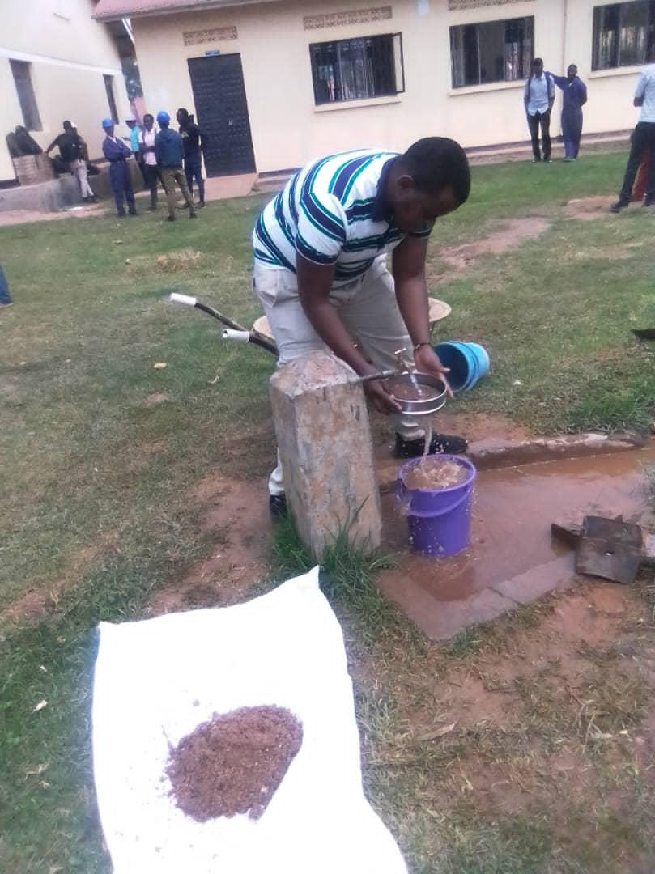

Figure 4: Washing sand for the filtration Column.

## DESIGN OF THE FILTRATION COLUMN

Two designs of the filter columns for the testing prototype and for the final prototype were generated.

### TEST PROTOTYPE

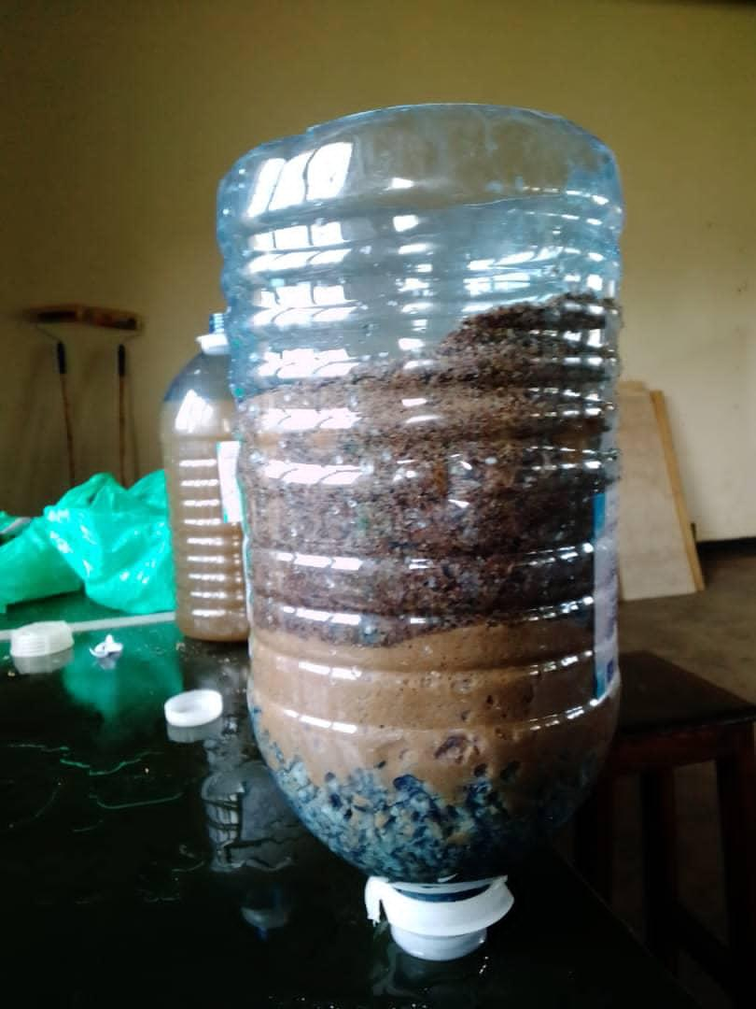

Figure 5: Test prototype

A five liter empty mineral water bottle (Rwenzori) was carefully cut off the bottom part open and created pores in its cover. The bottle had a diameter of 15cm at the bottom and had a height of 30cm after cutting the bottom open.

The filtration column had the 5mm aggregate above the outlet covering a height of 7cm, the 0.1mm sand covering a height of 5cm and 1.18mm sand covering a height of 8cm upwards respectively. And therefore leaving a head of 10cm as in the picture above.

### FINAL PROTOTYPE

A bucket of 37cm diameter and 80cm height was used.

A PPR melting machine was used to create a hole at the bottom of the bucket through which a long screw and back nut. Inside the bucket the long screw was connected to a T-system of perforated half inch pipes.

The filtration column was to have 5mm aggregate covering a height of 20cm, 0.1mm sand covering a height of 20cm, the 1.18mm sand covering a height of 20cm and the head being 20cm high.

Materials used to come up with the prototype are;

• Plastic bucket

• 3/4 inch PVC pipe

• 3/4 inch T- joint

• Long screw and back nut

• Female socket

• Thread tape

Tools used

• PPR melting machine.

• Hammer

• Tape measure

• Axle blade

• Adjustable spanner

• PPR cutter

• Roofing nail.

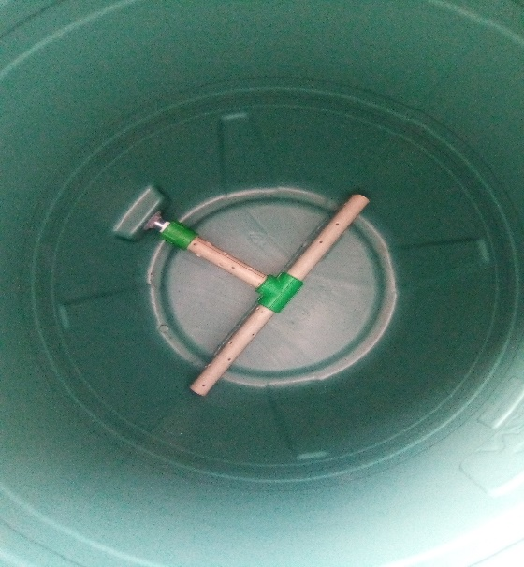

Figure 6: Final Prototype

## IMPLEMENTATION OF THE DESIGN OF THE FILTER COLUMN

The raw water was passed through the test prototype and I collected a sample after filtration which I took to the lab for analysis and I came up with results which are discussed in the next chapter.

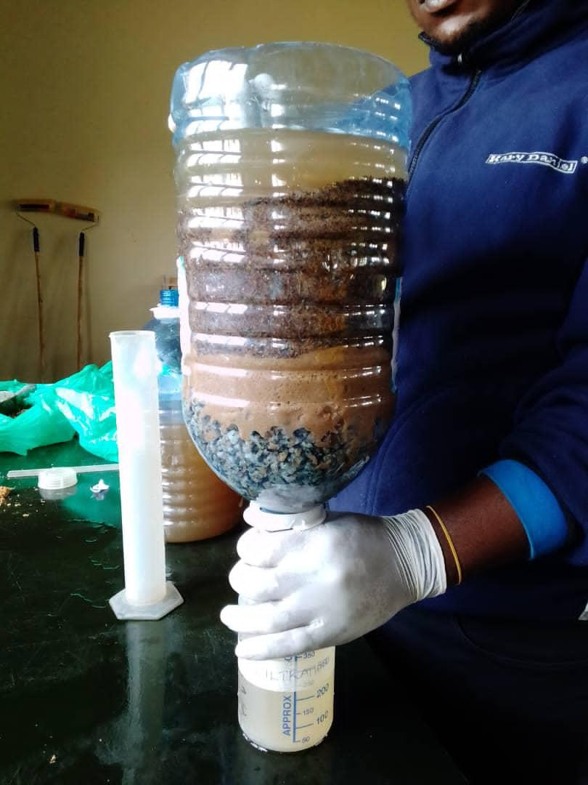

Figure 7: Raw Sample Filtration using the test Filter.

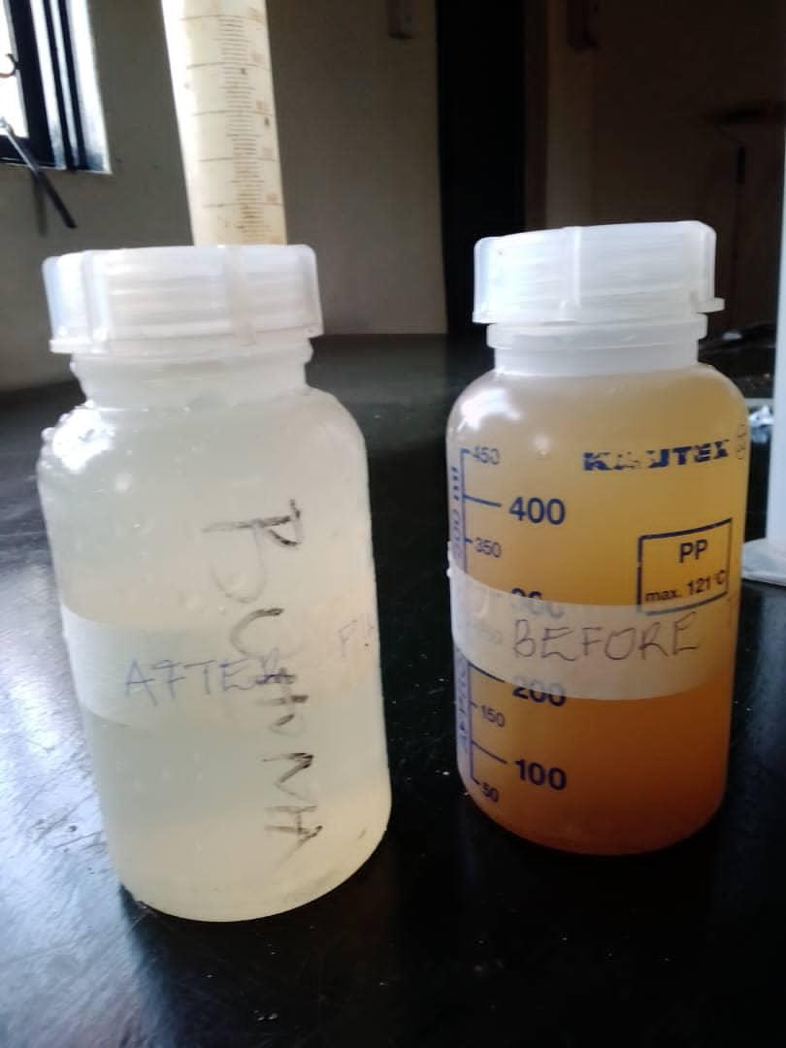

Figure 8: Samples before and after filtration. (L-R respectively)

# RESULTS AND ANALYSIS

## RESULTS

The characteristics of the raw and filtered river Kiruruma water that were obtained after using the initial prototype are summarized in the table below.

Table 2: Detailed Laboratory Results (Before and after filtration)

|  |  |  |  |  |  |  |
| --- | --- | --- | --- | --- | --- | --- |
| **Parameter** | **Units** | **Before sand filtration** | **After sand filtration** | **Guideline values for potable water** | | |
| **National standards** | **MAC** | **WHO** |
| PH | **-** | 7.13 | 7.42 | 6.5-8.5 | 5.5-9.5 | 6.5-8.5 |
| Color | PtCo | >> | 820 | 50 | 50 | 50 |
| Temperature | 0C | 20 | 20 | Acceptable | Acceptable | Acceptable |
| Turbidity | NTU | 190 | 92 | 5 | 30 | 5 |
| Total alkalinity | mg/l | 240 | 180 | 500 | 800 | 500 |
| Electric conductivity | µs/cm | 220 | 230 | 1000 | 1500 | 1000 |
| Chlorides | mg/l | 25 | 17 | 250 | 500 | 250 |
| Iron | mg/l | >> | 3.70 | 0.3 | 2.0 | 0.3 |
| Ammonia | mg/l | 0.64 | >> | 0.5 | 2.0 | 0.5 |
| Faecal coli forms | CFU/100ml | TNTC | 73 | 0 | 0 | 0 |
| Total coli forms | CFU/100ml | TNTC | 96 | 0 | 0 | 0 |

## ANALYSIS

From the physical-chemical tests done, both samples were highly colored with numerous visible suspended solid particles causing high turbidity levels.

The color may be due to presence of metals such as iron and presence of highly colored industrial and domestic wastes.

The sample before filtration showed exceedingly high iron level content which drastically reduced to 3.7 mg/l after filtration.

Ammonia was present in both samples at high levels. Though there was an increase in the levels after filtration which could have been as a result of use of rainfall tank water to flash the filtration media before filtering the raw water collected from river Kiruruma. Tank water was used because tap water was off. Also the increases in ammonia could have been as a result of poor handling of the sample at the laboratory.

Bacteriologically, the water samples were highly contaminated with coli forms; faecal coliforms and total coliforms which are responsible for various water borne diseases thus the water is not safe for human and animal consumption at this point.

The samples showed unsatisfactory physio-chemical and bacteriological characteristics of the water source which were not complying with guideline values for potable water.

# CONCLUSION AND RECOMMENDATIONS

## CONCLUSION

The study showed that further filtration is required to be done to lower color, turbidity and iron levels to allowable concentration levels. And it’s because of this reason that I came up with the second prototype as described in chapter 3.4.2 above where the height and diameter of each layer of the filtration media was increased so that more or all impurities are captured within the filtration media.

The study showed that there can be a significant change in amounts of water contaminants when raw water is filtered and thus it can change the health and sanitation of people who directly consume the raw water.

The implementation and use of the domestic sand filter for drinking water treatment for river Kiruruma water to lower the dosage of water treatment chemicals and tablets and reducing on over dependence of chemicals in treating water.

## RECOMMENDATIONS

* Studies to incorporate the aeration process should be done to remove ammonia through physical means as well as oxidizing dissolved iron in order to improve water quality.
* Water should be disinfected with chlorine in order to make it safe for consumption and further studies to determine the dosage of chlorine that can be used after using the domestic sand filter.
* There should be governmental or non-government organization that can support and encourage the improvement of the domestic sand filter in order to ensure safe drinking water for everyone.
* Studies to check the effectiveness of the second prototype.

# REFERENCES

Ashbolt, N. J. (2004). Microbial contamination of drinking water and disease outcomes in developing regions.

Community, E. A. (2014). EAST AFRICAN STANDARD Potable water — Specification. Arusha, Tanzania.

Goals, U. N. (2015). Millennium Development Goals. U. N.

Lee, T. (2001). Biosand household water filter project. Nepal.

S. Kayaga, J. F. (2009). Improved access to urban water services in Uganda. .

Sack, R. B. (1975). Escherichia Coli. .

Sparks, T. (2012). Solid-Liquid Filtration quality and productivity (First edit). . Heinemann: Butterworth.

Sutherland, K. (2008). Filters and Filtration Handbook (Fifth edit). Heinemann.: Butterworth.

Tien, C. (2012). Principles of Filtration (First Edit). . https://doi.org/10.1016/B978-0-444-56366-8.00001-3.

WHO. (2011). Guidelines for drinking water quality.

Wood, L. H. (1974). Slow sand Filtration.

# APPENDICES

Include project duration, costs and all data sheets, charts, pictures… that didn’t find space in the report body yet deemed important.

**LABORATORY TESTS BUDGET**

|  |  |  |  |  |
| --- | --- | --- | --- | --- |
| **NO.** | **ITEM** | **QUANTITY** | **UNIT COST** | **AMOUNT** |
| 1. | Temperature | 2 | 4000 | 8000 |
| 2. | PH | 2 | 7000 | 14000 |
| 3. | Turbidity | 2 | 7000 | 14000 |
| 4. | Electrical Conductivity | 2 | 7000 | 14000 |
| 5. | Alkalinity | 2 | 12000 | 24000 |
| 6. | Total Iron | 2 | 12000 | 24000 |
| 7. | Chlorides | 2 | 15000 | 30000 |
| 8. | Ammonia | 2 | 15000 | 30000 |
| 9. | Faecal Coliforms | 2 | 30000 | 60000 |
| 10. | Total Coliforms | 2 | 30000 | 60000 |
| 11. | Certificate of Results | 1 | 50000 | 50000 |
| **TOTAL** | | | | 328000 |

**SECOND PROTOTYPE BUDGET**

|  |  |  |  |  |
| --- | --- | --- | --- | --- |
| **NO.** | **ITEM** | **QUANTITY** | **UNIT COST** | **AMOUNT** |
| 1. | Plastic bucket | 1 | 26000 | 26000 |
| 2. | 3/4 inch PVC pipe | 2m | 2800 | 5600 |
| 3. | 3/4 inch T- joint | 1 | 9000 | 9000 |
| 4. | Long screw and back nut | 1 | 12500 | 12500 |
| 5. | Female socket | 1 | 8000 | 8000 |
| 6. | Thread tape | 1 | 2500 | 2500 |
| 7. | Rent for tools | - | - | 20000 |
| **TOTAL** | | | | 83600 |

**Long screw and back nut**

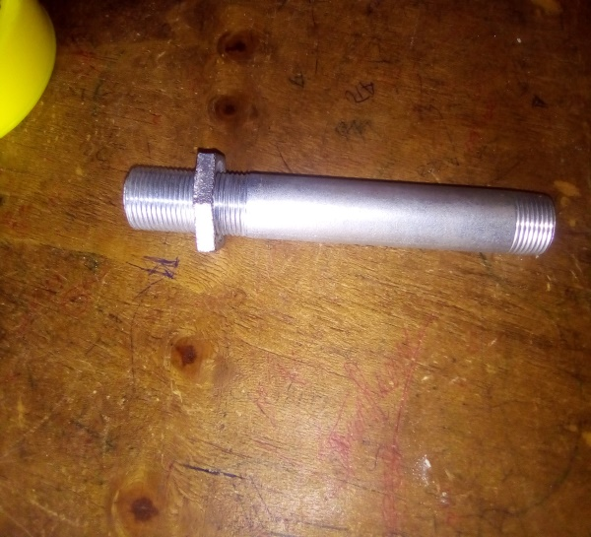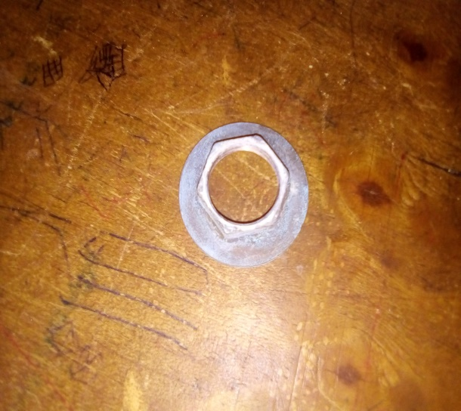

**Female socket T- joint**

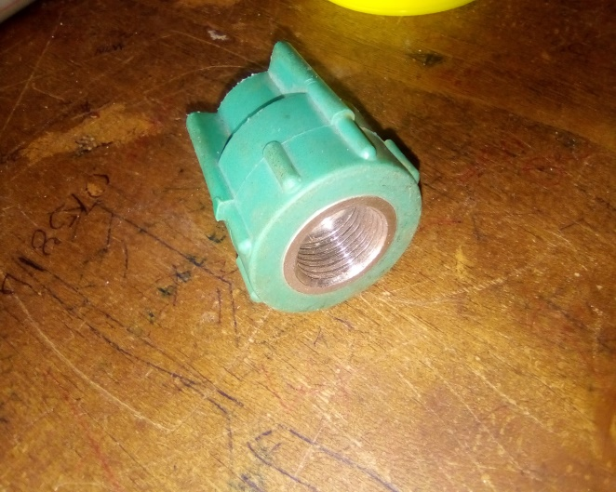 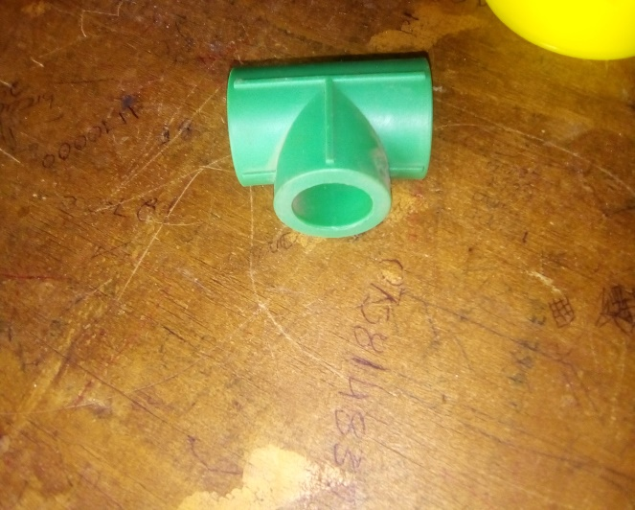

**PPR melting machine**

**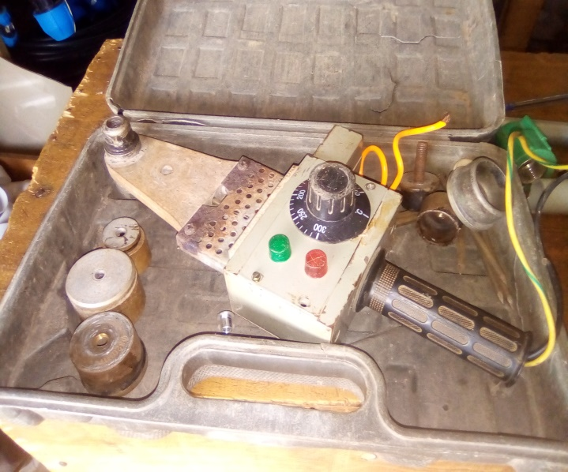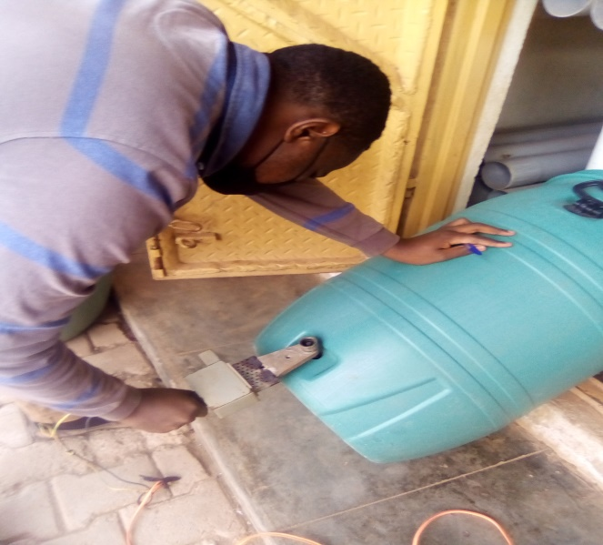**

**Sample collection from River Kiruruma at the bridge after Kabale NTC towards town.**

**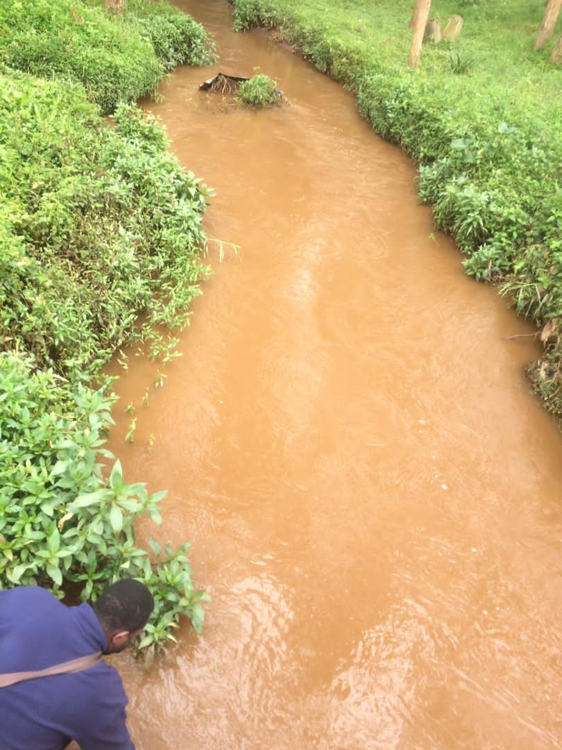**

**Preparation for filtration at Nyabikoni Campus Civil Laboratory**

**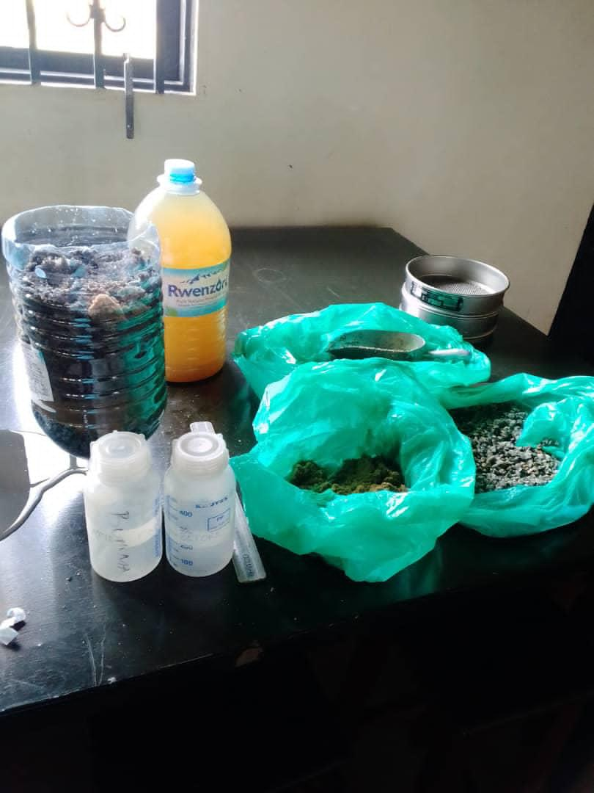**

**Filtering raw water collected from river Kiruruma.**

**