WASH – CIANJUR

Project Location | Cugenang District, Cianjur, West Java, Indonesia
Project Beneficiaries | 1000 People
Project Duration | 1 Month | Proposed start date | June 2023
Implementation Partner | Asar Humanity Foundation  Jl Raya Tapos. Number .17.A, Tapos, Kec. Tapos, Depok, Jawa Barat, Indonesia 16457

EXECUTIVE SUMMARY
Cianjur is one of the cities in West Java, which is located on the island of Java. Earthquake with a magnitude of 5.6 with the epicenter located 10 KM Southwest of Cianjur, West Java. The earthquake that occurred in Cianjur could be felt in a number of areas around Bandung, Jakarta, Bekasi. Residents who felt the earthquake in the surrounding area said that the earthquake that occurred did not experience any signs.

The survivors of the Cianjur earthquake, West Java, still lack sanitation facilities which include the availability of clean water and places for bathing, washing and toilets. Some of them use unclean water and defecate in the fields. Poor sanitation, rain, and unhygienic food make the refugees vulnerable to various diseases.
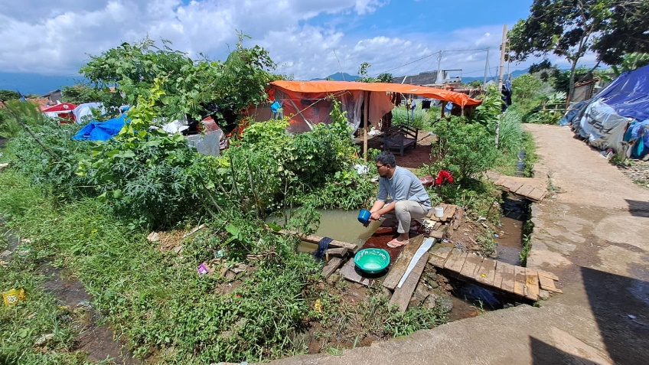

One of the ways to improve people's access to clean water is to propose a WASH (water sanitation) program in Cianjur, Kulawi District, Cianjur Regency, West Java.

- PROJECT BACKGROUND AND RATIONALE
Monday 21 November 2022 at 13.21 Local Time, there was an earthquake with a magnitude of 5.6 with the epicenter located 10 KM Southwest of Cianjur, West Java. The earthquake was triggered by a land fault, the Cimandir Fault. The earthquake occurred on land that has no tsunami potential.

The main earthquake occurred in Cugenang District and a lot of damage was done.

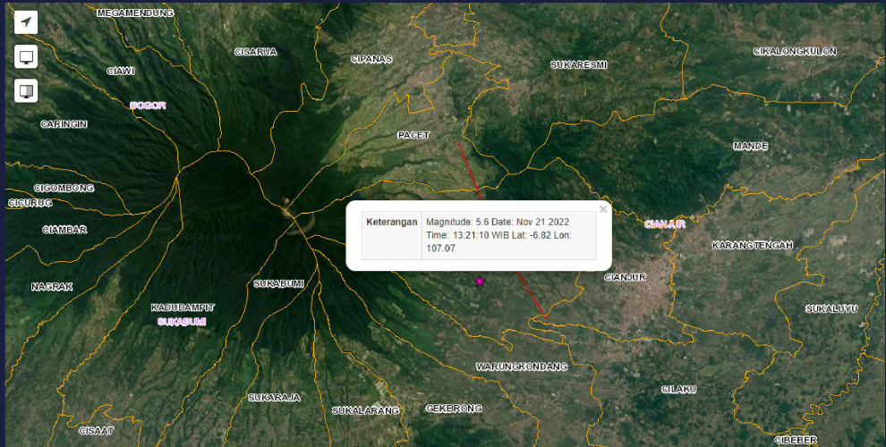

a lot of things are broken:
- ± 56.548 Damaged Houses (Data Collection)
- 18 Health Facilities Units (Cianjur Hospital, Dr. Hafidz Hospital, Cugenang Clinic, BKPM)
- 18 Government Building Units Damaged (Kodim 0608/Cjr, BPBD, PUTR, Cianjur Prison, Attorney, Police, KONI, Social Service, PCNU Office)
- 701 Education Facility Units Damaged (Smanda, Dewi Elementary School, High School etc)

The impact of this incident resulted in damage to houses, buildings and shops as well as causing victims both injured and dead. And landslides have occurred in several places.

Here are the victims of the earthquake:
⮚602 Died
⮚5 people buried under the rubble (in the process of searching)
⮚593 Cumulative Serious Wounds

And ± 114,683 Refugees spread across 453 centralized and independent evacuation posts in Cianjur. Everyone is just in tents or temporary shelters for now before they have their own homes again. This means that many water sources have been damaged, so that the affected communities cannot have access to clean water for their daily needs, even for daily consumption.

- Statement of the problem and how the proposed project aims to solve the problem:
Limited access to clean water to meet their daily needs contributes to the hygiene and sanitation problems of the Cianjur people, they only use what they have, such as simple water sources from rain and streams of water that flow from the fields. This is the condition of water and sanitation sources in the Cianjur area today. Another, more important, effect of this situation is that the people are exposed to skin diseases because the water they consume is unhygienic.
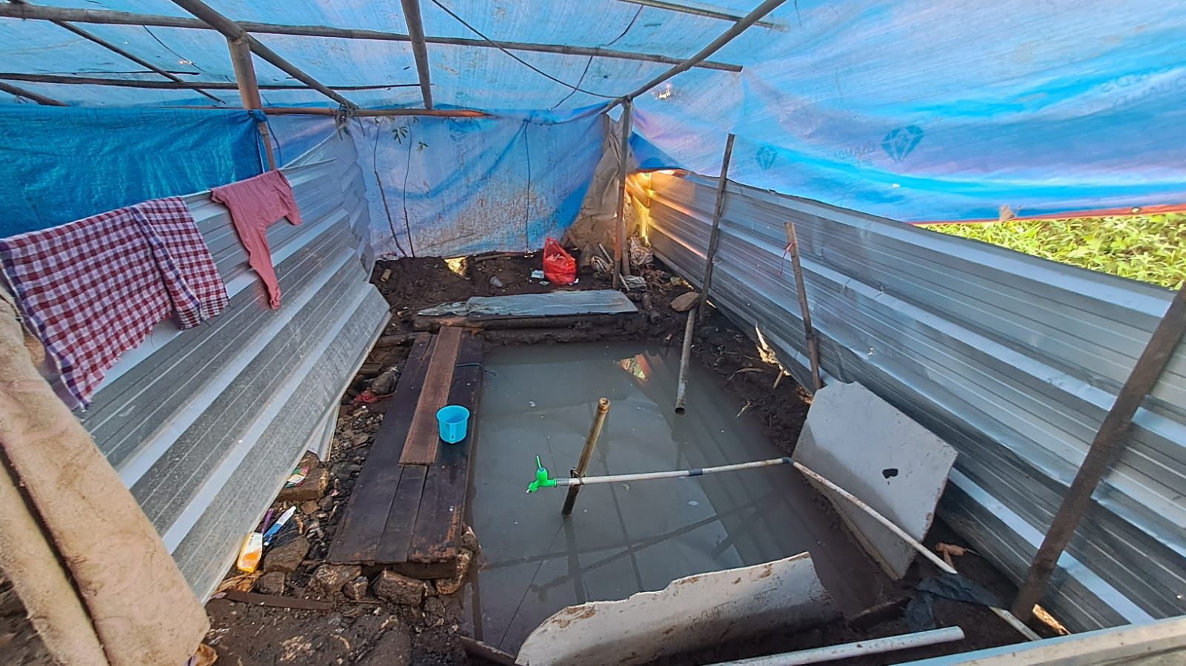
- How project requirements are determined:
The level of need for this project was determined from the results of an assessment and coordination with local government stakeholders regarding the sanitary condition of access to clean water in waterways following the Cianjur earthquake. As well as paying attention to the community's urgent need for clean water to meet their daily needs.

- How beneficiaries are involved in project identification and planning:
Communities are the main actors in this project; related parties are involved in the assessment of the project location up to the management of facilities and infrastructure. The maintenance and management of these facilities is entirely the responsibility of the community.
- Intervention on the spot by proposing other NGO organizations.
Interventions conducted at the project site by other non-governmental organizations (NGOs) will be tailored to their roles and responsibilities. So that the distribution and execution of each task is clear.

- PROJECT DESCRIPTION
- Beneficiary profiles, both directly and indirectly;

      - Kampung Lebak Songgom, Telaga Village, Cugenang District

- There are 130 families which consists of 390 people
- Currently, water source of the people only coming from water well (25-meter-deep) and water stream from a village above it. The water well is no longer ideal to supply all the water demand from the people. The water streams that come from a village above is most of the times unclean and contaminated by household waste. Sometimes, other animals such as chicken and birds also contaminate the water by its fesses
- Due to unknown factor, people’s water well is dry. As a result, the water supplies is not enough to fulfill the demand from people’s necessities
- Due to unavailable WASH facility, people still use emergency toilet and pond for daily activity. This condition felt by all of the area

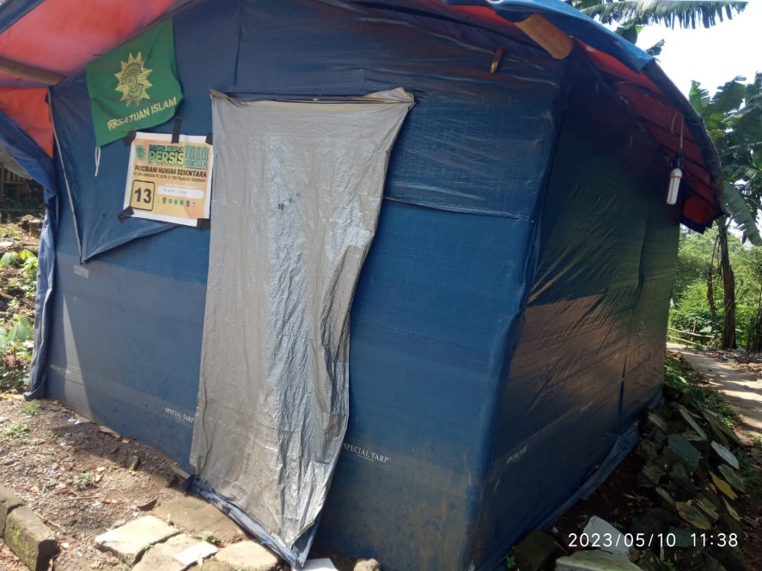

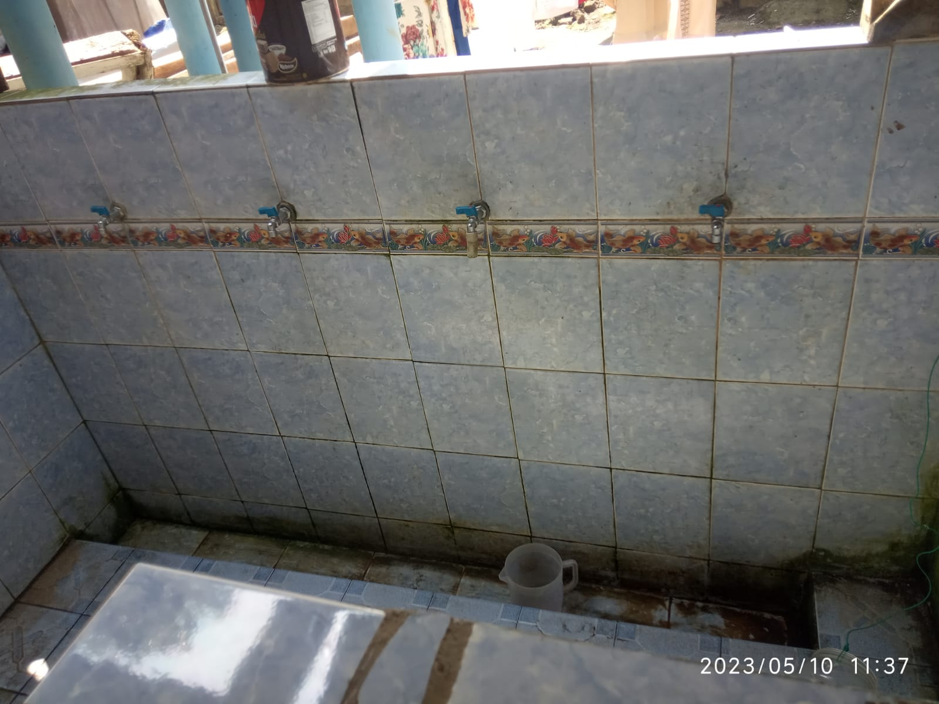

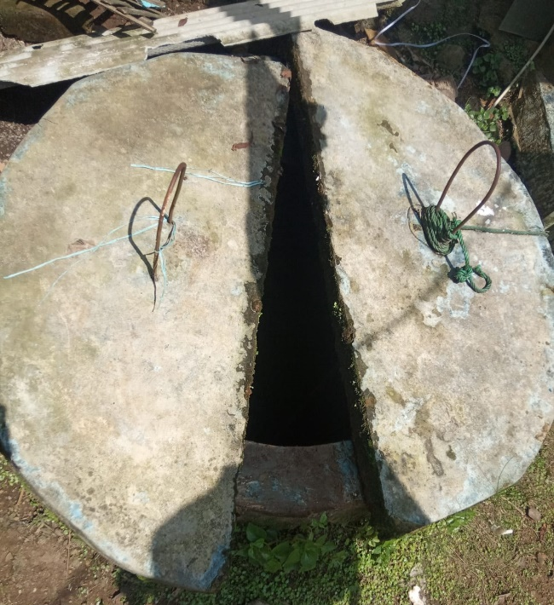

      - Kampung Tipar, Ciwalen Village, Warungkondang District

- There are more than 100 families which consists of more than 300 people
- Currently, the only water source for the people is coming from water well (20-meter-deep). However, the well is originated for mosque and pray purpose only, that is why people cannot take the water carelessly for other usage
- The condition is worsening by unhealthy lifestyle of people and toilet which needs to be renovated, not to mention counseling and health promotion needs to be done in the area
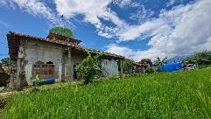
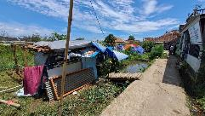
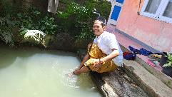
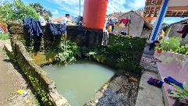
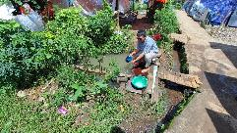
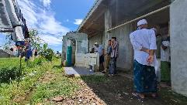
- Due to unavailable WASH facility, people still use emergency toilet and pond for daily activity. This condition felt by all of the area

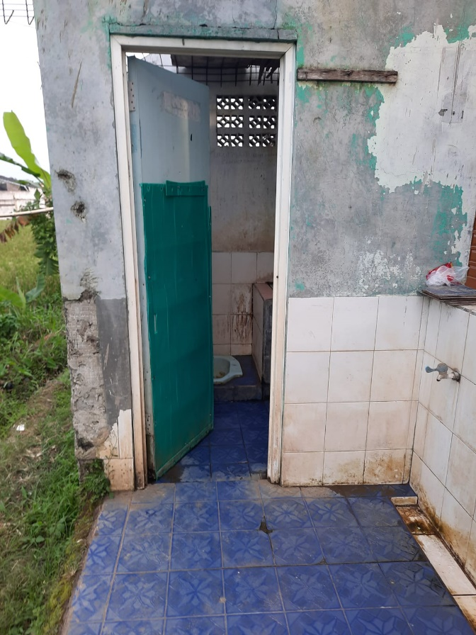

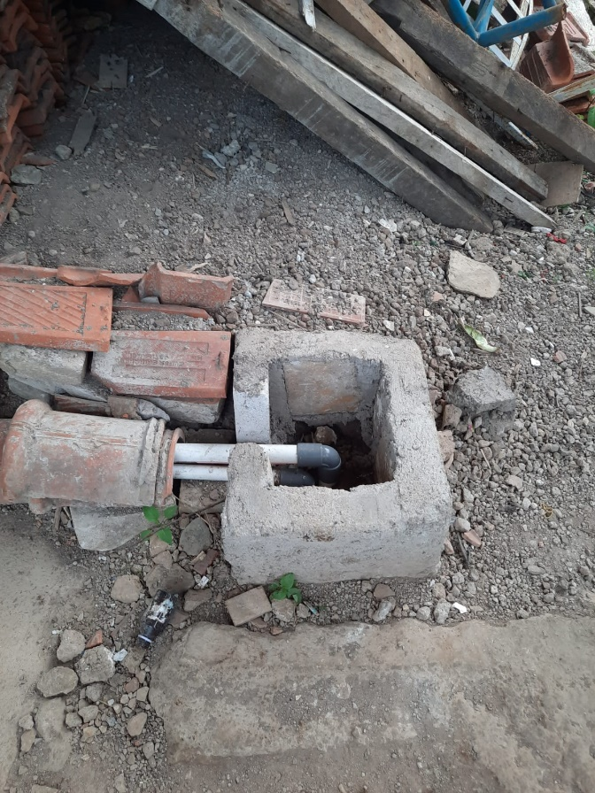

      - Kampung Babakan Bunisari, Nyalindung Village, Cugenang District

- There are 100 families which consists of 300 people
- Currently, water source for the people coming from water well (20-meter-deep). Unfortunately, numerous water well is receding and turbid. This will result for a need new water well which is 30 meter deep and more
- The unhealthy condition also makes the people to get counselling and health promotion in the area
- Due to unavailable WASH facility, people still use emergency toilet and pond for daily activity. This condition felt by all of the area

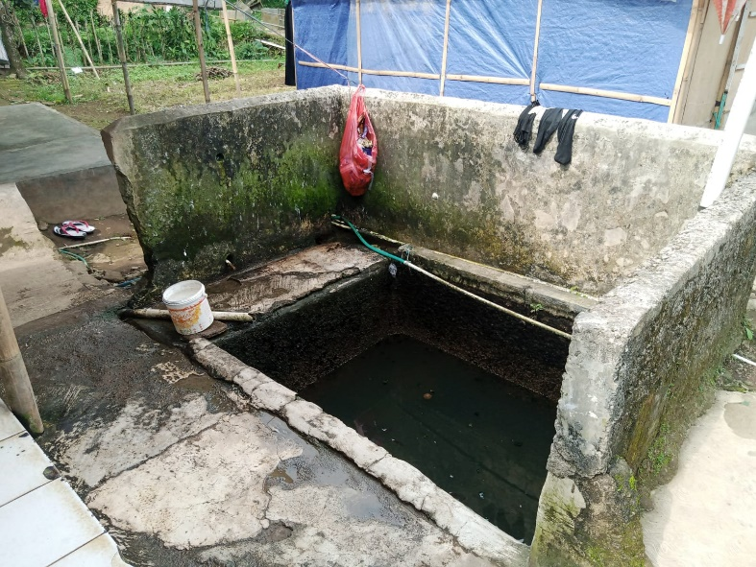

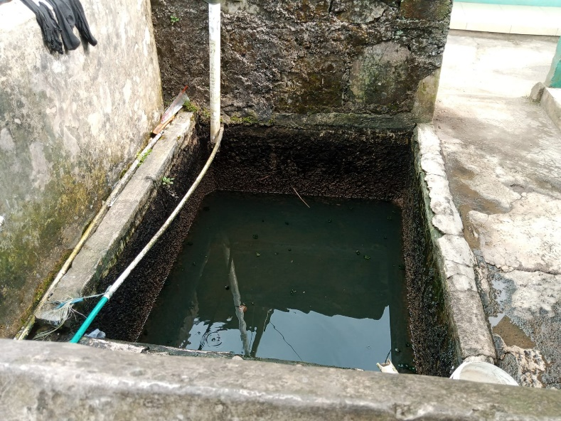

- results and output targets:
The following are the objectives of this WASH :
      - Construction of wells
      - Toilets with 4 doors at 3 points
      - Wash Place in 3 points
      - Water Storage in 3 points

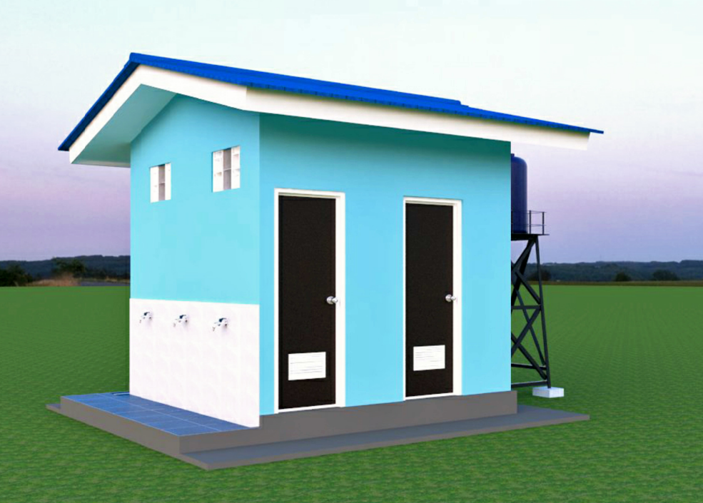
Side view

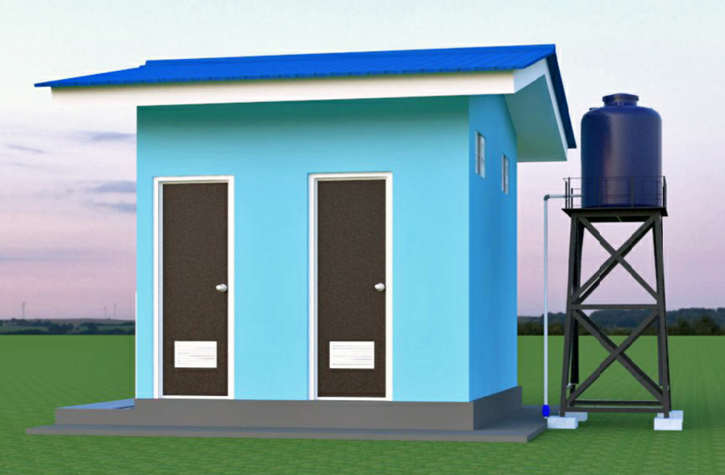
Front View

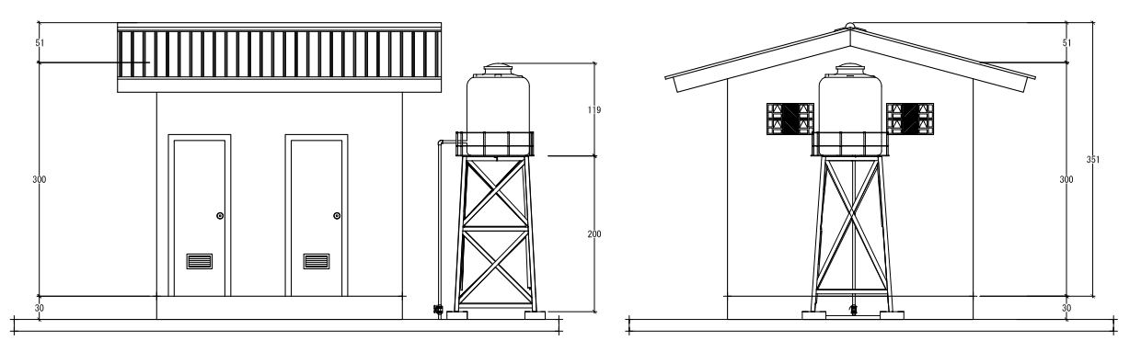
Front View Side View
Scale 1 : 50 Scale 1 : 50

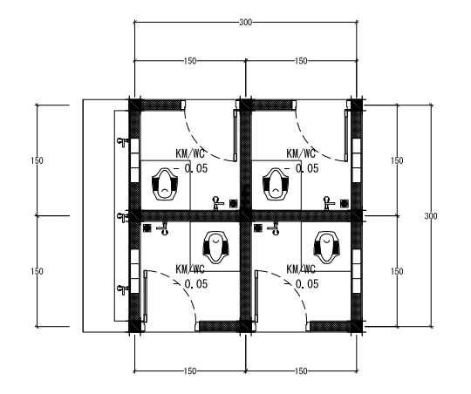
Scale 1 : 50

- Project execution plan and timeframe – will be presented according to Template B1

- Profile of beneficiary targets, both directly and indirectly; The target beneficiaries are Cianjur residents who are survivors of the Cianjur earthquake. The water will be used for daily needs and also for farmers who need water for their agriculture in this area. Sustainability plans for proposed interventions, including whether the project is expected to continue or expand to other areas after the completion of the current phase of assistance. This could include plans to implement self-financing provisions, etc; The project sustainability plan will be communicated to the community after it is fully managed and monitored by local stakeholders. Furthermore, we hope that this program can be expanded to several areas in Cianjur that are in dire need of clean water facilities. Considering that many post-earthquake infrastructures have not been utilized optimally.

- MONITORING & EVALUATION
- M&E Management: Who will be responsible for implementing the M&E plan, including preparation of periodic project progress reports and cost accounting
- The project is being executed by the vendor, who will keep reporting the progress of the work on a daily basis. Furthermore, ASAR Humanity will continue to coordinate with the project coordinator on a regular basis after the ASAR Humanity team has conducted monitoring and evaluation in the field.

- Participation: How will you involve beneficiaries and other stakeholders in the monitoring and evaluation of the project? (For example, beneficiaries help design the program and identify targeted outcomes; for example, in the middle of the program, we will hold a share and learn session to share interim results and discuss further program improvements). -
In implementing this project, we will involve community participation which includes:
- Evaluation of determining the location and point of implementation of the project through FGD (Forum Group Discussion) sessions with certain stakeholders.
- During program implementation, the community will work together to make the program successful.
- Once construction is complete, a special committee will be established to manage and maintain the facility under the supervision of local stakeholders.

- Data collection: How will you collect data to report on each output and outcome listed in Appendix A? -
The data collection process is divided into two stages, namely as follows:
- Narrative data, which will be collected directly from the vendor and the person in charge of the field, a daily summary of the progress of the project implementation.
- Financial data, which will be collected from the vendor in charge of implementing this project.

- Continuous learning and development: How will you ensure continuous improvement (i.e., that lessons learned are understood and implemented as the program progresses)?
The continuation of this program is expected to result in improved public health and increased public awareness of the importance of clean water sanitation in everyday life.

- RISKS & CHALLENGES
This section discusses the risks, issues, assumptions, challenges, and sustainability concerns associated with the proposed project's successful implementation. The proposing organization must also include a strategy or plan of action to mitigate potential risks and address anticipated challenges.

As part of an effort to reduce these risks, issues, assumptions, and challenges. At the outset of the assessment, we will reach an agreement with community representatives and local stakeholders to share responsibility for this project. The formation of a community-based community that is specifically responsible for managing these facilities is the follow-up plan to reduce this risk.

- PROJECT BUDGET
Template B

- IMPLEMENTING PARTNER – BACKGROUND & OPERATIONAL CAPACITY
Asar Humanity Foundation

ASAR Humanity was founded on November 1 2018, present as a Humanitarian Institution that contributes to solving the biggest Humanity problem, namely POVERTY. With the aim of mobilizing community social care, in order to give birth to a just, prosperous and prosperous social order.
Along with the generosity of the community and the spirit of volunteerism, ASAR Humanity currently focuses on the 5 (five) pillars of Beneficial Energy, namely: Emergency Response, Education Assistance, Food, Health, and the Islamic World.

As a testament to the determination to spread kindness and expand benefits, ASAR Humanity together with the movement for the good of the people, institutions, and companies, have contributed to every issue of the Humanitarian crisis throughout Indonesia and the world.

Vision
To become a Global Humanitarian Institution that mobilizes global civil society concerns for the creation of a just, prosperous and prosperous society.

Mission
- Together with all elements of society continue to move usefully by making programs that are directly felt by the community from various needs.

Some of ASAR Humanity’s Experience:

      - Emergency response in Semeru Eruption
Asar Disaster Response Eruption of Mount Semeru, Lumajang. The AVIATION Asar Humanity Team carried out the Call for Troops to Search and Evacuate Victims of the Mount Semeru Eruption Led by the Main Command Post in Candipuro Field.

- Flood In Jabodetabek
ASAR Disaster Emergency Response Flood Response by the Volunteer Asar Humanity team in the JABODETAK area, floods hit at several points in the area, affecting many people.

- Pipenization Mamuju Earthquake
The earthquake that hit Mamuju-Majene, West Sulawesi in 2021-2022 resulted in many houses still being destroyed and some people still traumatized by the earthquake that reoccurred, forcing those living on the coast to evacuate to higher ground. The water in the refugee camps forced the community to have to go back and forth from the water source to the refuge location which was more than 500 meters away. Asar Humanity provided facilities in the form of a water pump and piped water from the source to the evacuation point

Annex A | TARGET OUTPUTS & OUTCOME

TARGET OUTPUTS

Activity |  | Target output
1 | Build a water wells, toilets, and deliver water gallons for the communities affected | a | 6 water wells
 |  | b | 6 Toilet with 4 doors
 |  | c | 250 gallons of water / day
Above table to be copied into Template B1 – Project Implementation & Timeline.

